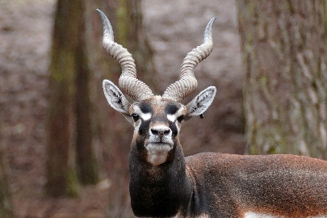
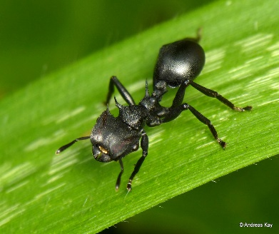
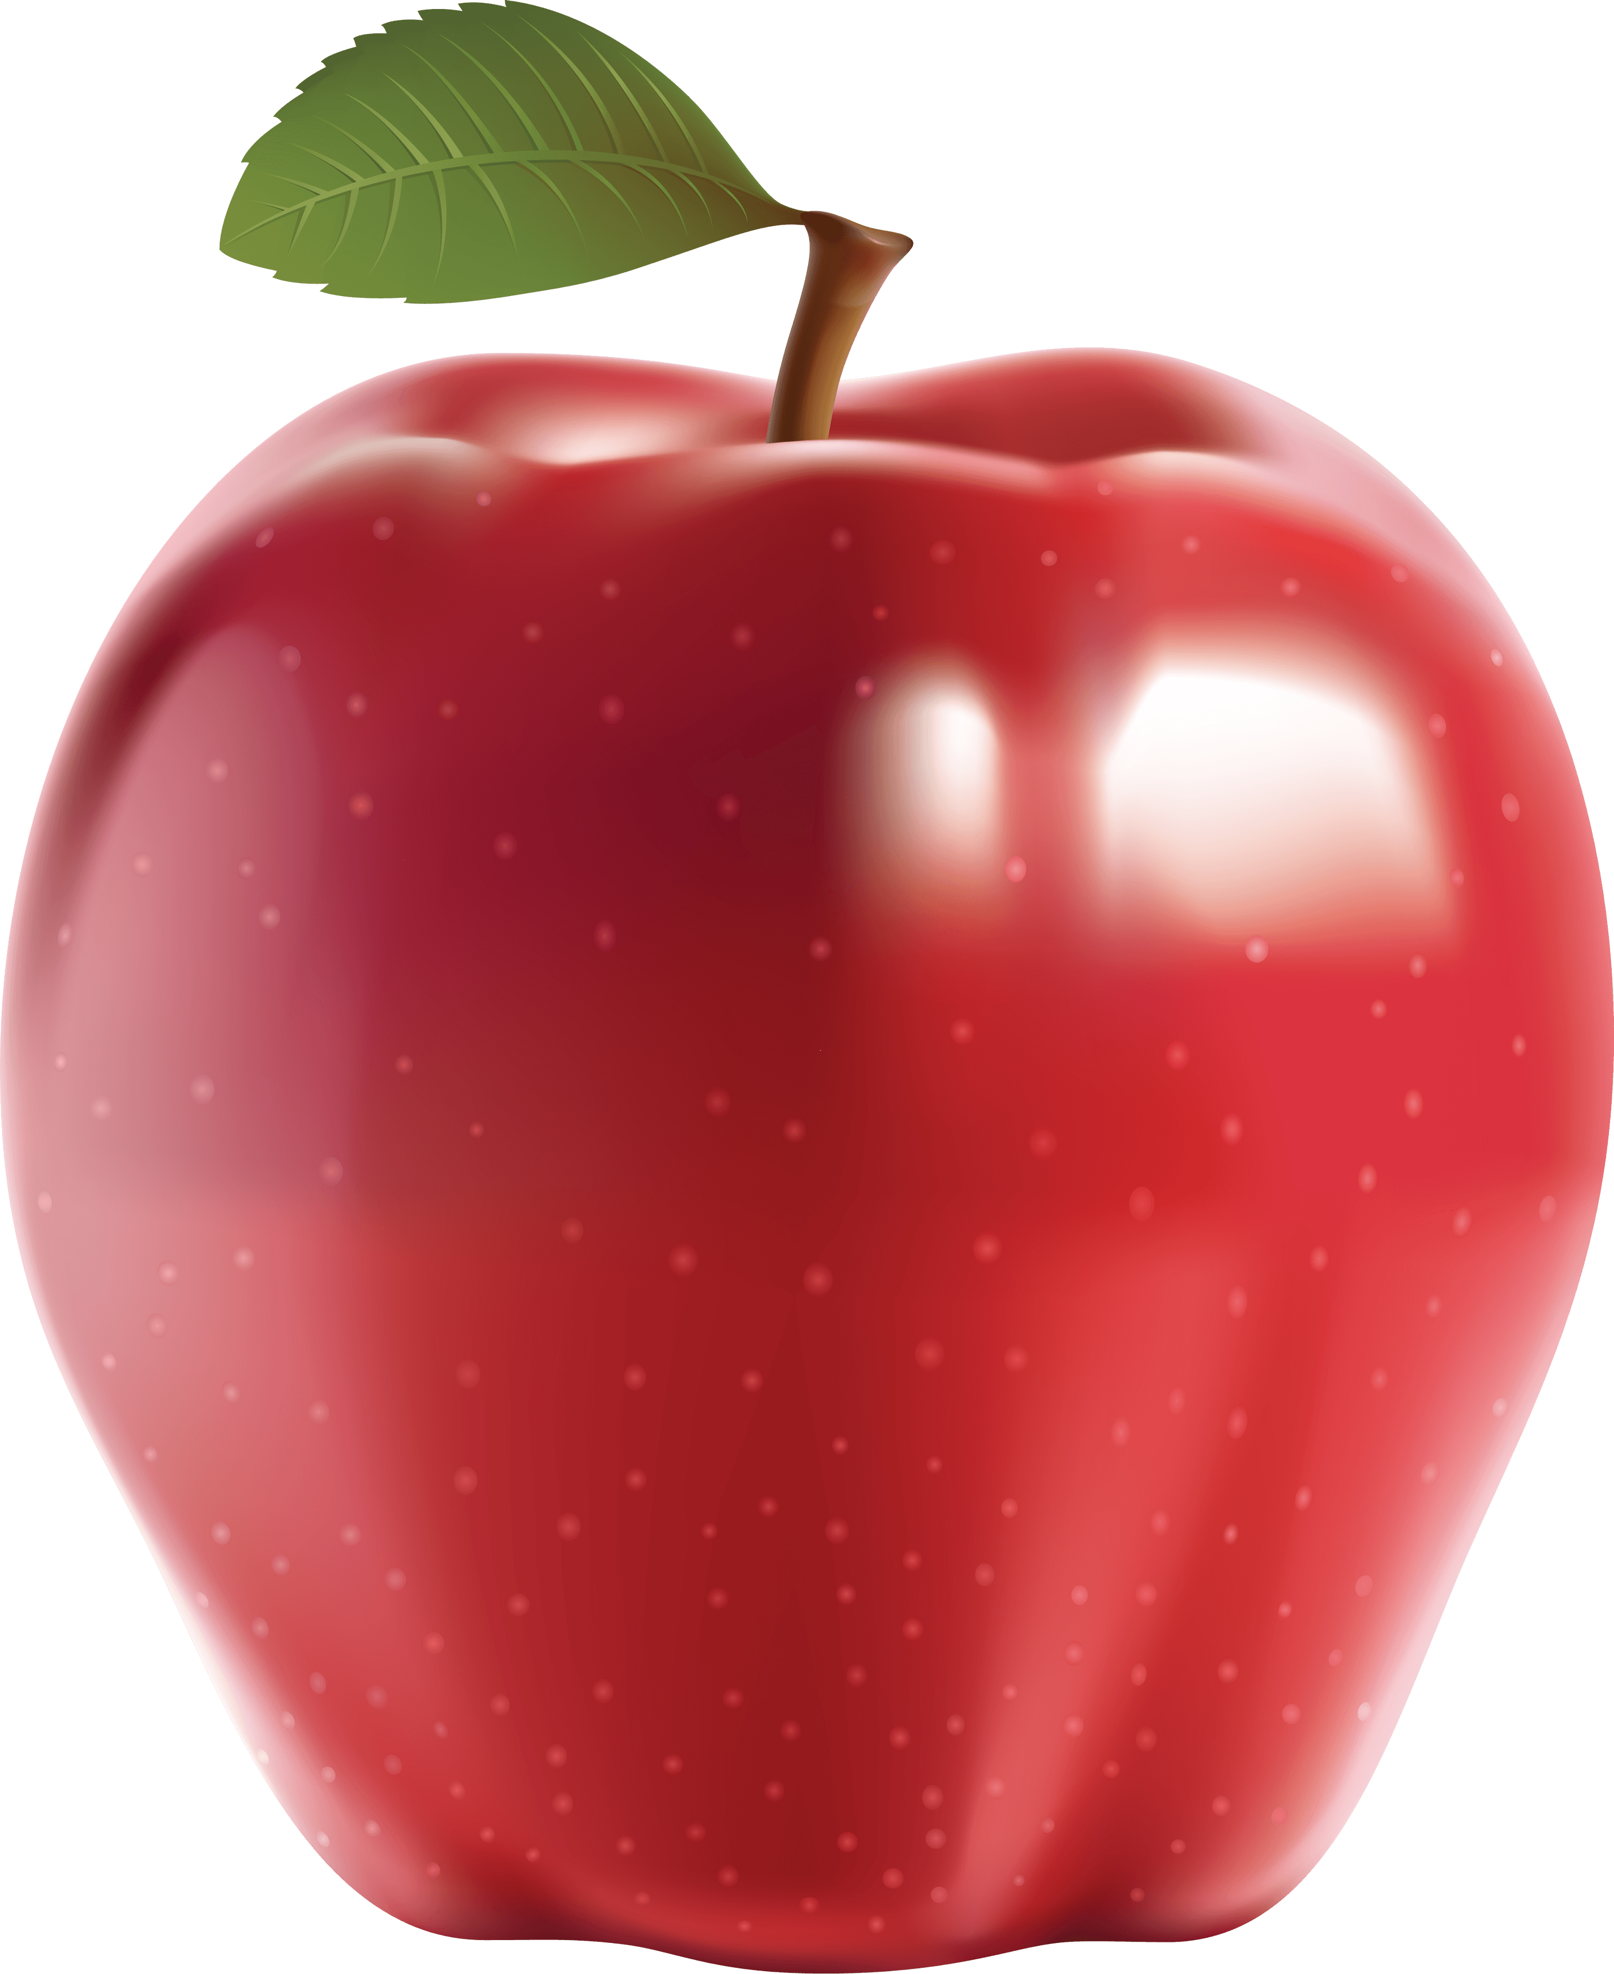
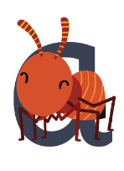
a
This Photo by Unknown Author is licensed under CC BY-SA-NC
This Photo by Unknown Author is licensed under CC BY-NC
around the head, down the body
a a a
a a a a a a a

