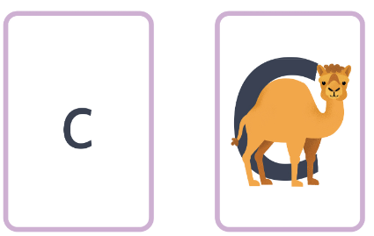
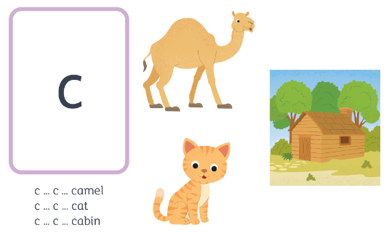
camel – curl around the camel’s back
c c c ck m
c c c c c c c c c

