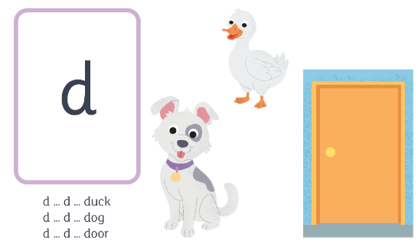
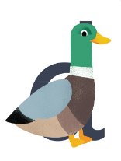
d
d d d m
over his back and around the tail, up his neck and down to his feet
d d d d d d d d d n n

