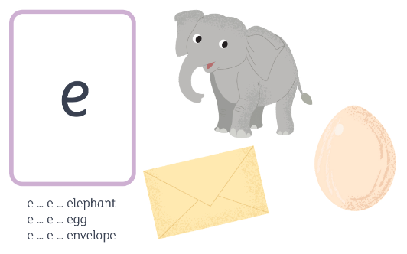
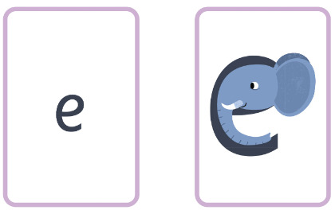
e e e ck m
elephant – around the head and down the trunk.
e e e e e e e e e

