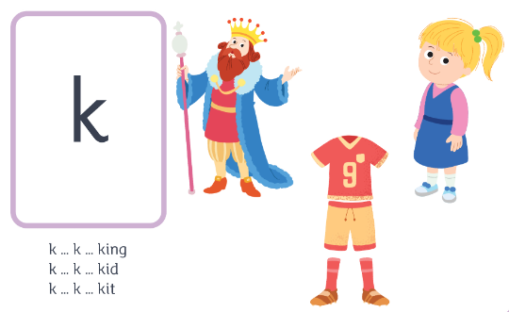
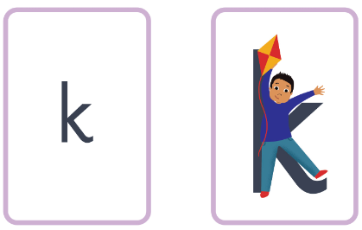
Kid – down the body, up the arm, down the leg.
k k k ck m
k k k k k k k k k

