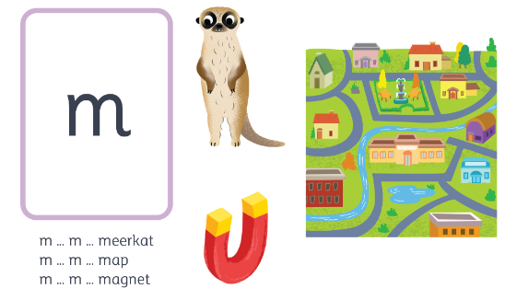
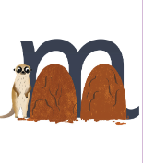
m
Meerkat, mound, mound
m m m
m m m m m m m m m n n

