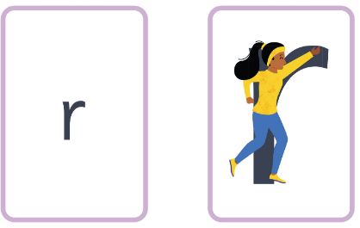
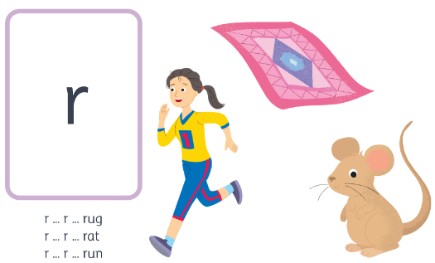
runner- down her body, up over the arm.
r r r r ck m
r r r r r r r r r r

