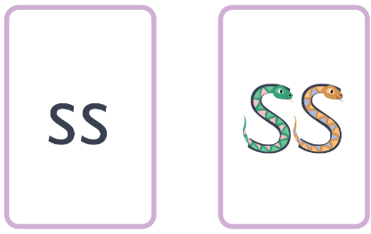
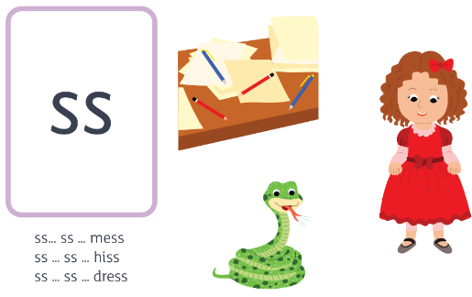
Two snakes - sunbathing snakes.
ss ss
ss ss ss ss ss ss ss

