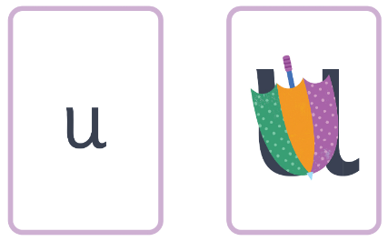
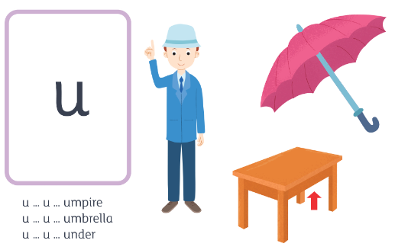
umbrella- down the umbrella and down to the tip.
u u u u u ck m
u u u u u u u u u u

