

The Crescent Primary School English Policy

The vision
At The Crescent Primary, English teaching is a core foundation across all of our curriculum subjects where rich opportunities for reading and writing are applied in a range of contexts. In doing so, our pupils are offered a wide and varied curriculum in which they can master skills of communication to support them in the wider world. Diversity within our curriculum is a fundamental aspect of our core beliefs and values; our text drivers are chosen to provide an inclusive approach for all pupils, where they feel identified, valued and celebrated through writers, characters and settings that represent cultural diversity.
In line with our REACH school values (resilience, evaluative, ask questions, challenge and help one another), opportunities to achieve these values are embedded within our English curriculum. We aspire for our children to engage with our curriculum with enjoyment and wonder. We want our children to develop a love of language which is vital to strengthen their ability to enquire, respond and express themselves. We seek for our children to ask questions and become critical of what they are accessing and creating, practised through skills of analysing, inferring, editing, re-drafting and reflecting.
Our learning journeys are used across the school to provide pupils with clear insight into the purpose, form and audience whom they are writing for. Our children are encouraged to think in role as a particular writer with a particular voice, including as poets. Through the use of apprentice writes children are able to frequently apply prior learning in new contexts. Our showcase writes come at the end of our learning journeys and encompass skills taught to date. We endeavour that children have a shared love of writing by exposing them to a wide, diverse and high interest text-led curriculum, whereby books are the heart of writing. This is complimented by mixed media for a multi modal approach, including film, advertising, news and real-life campaigns.

The Crescent Primary School English Policy
Phonics and early reading:
In Phonics, children follow the Essential Letters and Sounds programme from the beginning of Reception. It uses a simple, consistent approach to teaching and aims to get all children to read well, quickly. It uses mnemonics and rhymes to support learning and recall. The scheme teaches four new sounds a week and has a fifth day dedicated to revisit and review, and applying reading skills by reading decodable books in class.
This Synthetic systematic phonics (SSP) programme teaches children the link between the sounds of our language (phonemes) and the written representation of these sounds (graphemes), or the spellings of the sounds contained within the English language. Essential Letters and Sounds is a complete Systematic Synthetic Phonics Programme (SSP). Essential Letters and Sounds is our chosen phonics programme.
The children will follow this programme throughout EYFS and Key Stage 1 and will use this as their basis for spelling throughout their school journey.
Although English is taught through the four strands of writing, reading, spelling and grammar, our ethos is to ensure learning encompasses all of these taught skills and children are given regular and purposeful opportunities to apply these across the curriculum.
Aim of phonics for children:
• learn 44 sounds and the corresponding letters/letter groups using simple picture prompts
• learn to read words using sound blending
• read lively stories featuring words they have learned to sound out
The children:
• learn to write the letters/letter groups which represent the 44 sounds
• learn to write words by saying the sounds and graphemes
• write simple sentences
How do we teach Essential Letters and Sounds?
With ELS, phonics is taught daily from the beginning of Reception, throughout Year 1 and into Year 2. The teaching of Phase 2, 3, 4 and most of Phase 5 are taught in Reception. Phase 5 and ‘beyond’ are taught in Year 1.
In each lesson the teacher teaches a new sound or reviews sounds taught earlier in the week. Children learn the letter or group of letters that represent the sound. A picture and rhyme accompanies each sound to help the children remember it.
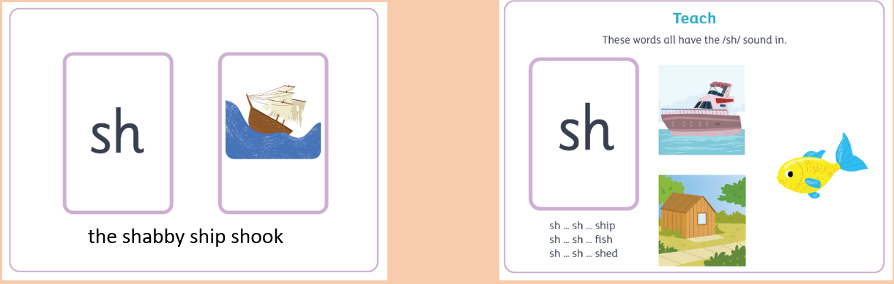
Children are asked to read words and sentences with the new sounds in. This is practiced with the whole class on the whiteboard.
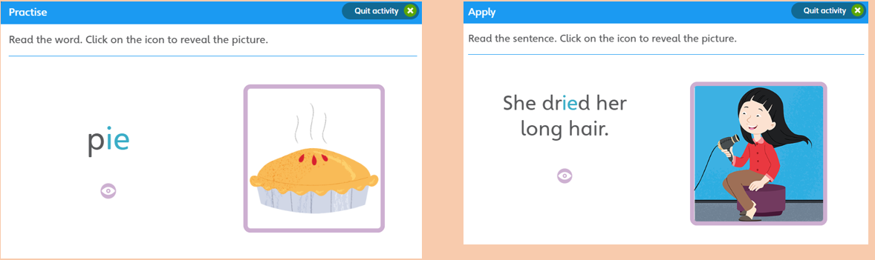
Children then have a go reading words and sentences with the new grapheme in their work book.
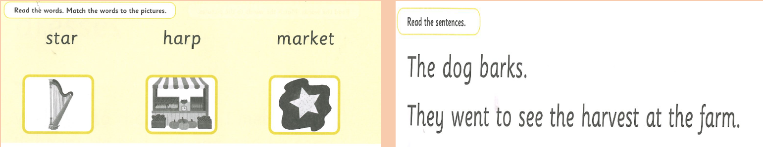
Teaching of Phonics:
Year R and Year 1 children complete a daily 20 minute session learning the first set of sounds in preparation for reading. Pupils in Year R learn phases 1-4 and most pupils will secure phase 5. In Year 1, pupils learn phase 5 and beyond. If pupils need additional catch up intervention, this will be tailored to previous phases. Interventions are held at different times to daily phonics teaching so that pupils do not continue to fall behind.
To support with letter formation, in EYFS, pupils follow the phase 2 rhymes to help learn the movement and shape of letters. In every lesson, children practise writing the new grapheme they have learnt. Continuous provision for pupils offers opportunities for this weeks phonics teaching and recaps prior learning. Children are encouraged to write in full words and sentences containing their new taught grapheme. The model of teaching and applying new learning is: say the word, stretch the word, segment the word, blend the word, count the sounds in the word, say the whole word.
Year 2 children should already have a good knowledge of phonics and will be consolidating this work through applying it to their reading and writing. There is likely to be some children who will need to continue this in Year 3 in tailored intervention. Phonics intervention happens 3 x per week with an intervention When children are in Year 2, they will begin to follow the ‘No Nonsense’ scheme for spelling within their normal English lesson; this is in addition to phonics teaching.
In Years 3 – 6, some children will need revision of the phonics programme for 20 minutes 3 or 4 x per week. Pupils who did not pass the Phonics screening test in KS1, are a key focus for the class teacher and within intervention teaching for small group phonics. As some children will require further catch up with phonics, additional intervention will continue for small groups teaching into the spring term and beyond. Children will be assessed throughout the year inline with the ELS benchmarking, in addition to reading age tests. Once pupils have secured the appropriate phases, pupils will continue with the No Nonsense spelling programme solely. All other children in KS2 will solely follow the No Nonsense Spelling programme progressively from Years 3-6.
Reading:
Reading is taught daily across the school and each year group has a daily guided session for 30 minutes, or four 40 minute sessions per week. In EYFS, pupils study a whole class text which each week in addition to story time. In Year R and 1, pupils also learn their weekly decodable phonics book which is taken home to read with families each week. In Year 1 - 6, pupils study a whole class text for part of every learning cycle, then complete a carousel of learning in accordance with Badger books scheme learning. During a guided reading lesson, there are two distinct teaching phases:
Whole Class Model/apply phase
During a whole class model/apply phase, the class will all study the same text. This will enable all learners to have access to a rich and challenging text. During these lessons, the teacher will model skills to the class which they will then continue independently. There are layers of challenge (star challenges) within these lessons, where children can demonstrate their skills and understanding. These skills are often interlinked within English learning journeys to further support children with opportunities for practicing reading skills within other contexts.
Independent apply phase
During the independent apply phase, the children are split into differentiated groups where they have a text that is appropriate to their ability. The children will all complete the same activity e.g. make inferences about a character, but they will do this independently about their own group text appropriate for their level of challenge. The school uses a reading scheme called Badger Books across Key stage two for the independent reading apply phase.
Assessment of reading:
During guided reading lessons, teachers make informal assessments about groups of children and plan what needs to be taught next to enable those children to make progress. Informative notes of pupil reading are kept within the class reading records folder. At the end of each term, summative assessments are completed (NFER reading tests) which enables each child to be given a scaled score for reading. This helps to validate teacher judgements and pinpoint areas for whole class focus for future planning.
• In KS1, children will be assessed termly using formal Benchmarking, in addition to using the ongoing Hampshire Assessment Model objectives for reading. Common exception word practise (verbal test) is completed termly linked to key words from Year 1.
• Once a term, all across years 2-6 children will complete a NFER Reading Comprehension. This will be administered as a test suitable to the age of the children – Year 2 pupils will complete in small groups in the same way that they would complete their SATs test.
• Reading scores will be recorded termly on INSIGHT as scaled scores.
Reading for pleasure
Reading for pleasure is fundamental at The Crescent. All teachers ensure that they read a story at the end of the day with their class. Class reading books are aspirational reads for the class and it is always aimed for these not to be books the children have already read. They should inspire the children to read others by the same author, or similar genre.
Every half term, we hold the Reading Café Monday – Friday. Parents and Carers come into school to read with their child from 9 – 9:30am. Squash, tea and biscuits are served and children sit comfortably on blankets, mats, bean bags and chairs with their family to read. There is no charge for the event. In the classrooms, children have their own reading café there too, with a tailored task to promote a love of reading. Squash and biscuits are provided in the classrooms too.
We participate in reading awards organized by Hampshire SLS, Year 1: Picture Book Award. Year 4: Information Book Award. Year 5: Illustrated Book Award. These awards help to promote new books to the children during their guided reading. The collection of books is then passed to the parallel year group for them to enjoy.
Each teacher listens to every child read at least once during the week. Pupil premium children are provided with 3 opportunities per week to read to a dedicated adult in addition to reading with their class teacher. The lowest 20% of readers in each class are identified by the class teacher and these children become priority readers, whereby they are focus children in class, discussed at half termly pupil progress meetings, are focus children for changing their library books each week and heard reading by the Senior Leadership team.
Reading Ambassadors:
Reading Ambassadors play an important role in school. They opt into the role by applying to the reading leader. They meet half termly and support the reading leader with Reading Café, reading week, book events, the reading barn, choosing ‘class dates with a book’, organising the library and purchasing new books for school.
Reading Books
Sets of books for each year group, linked to each year groups curriculum, will be used in the classroom. These books will be used in class to teach skills identified in The National Curriculum and will link to the medium term planning. It is important to make sure the teacher promotes a range of genre, breadth and balance of these books.
Texts will need to be carefully prepared in order to ensure the teaching of reading skills as well as deepening reading for pleasure.
Book Corner
In every class, there is a book corner and a display for the book corner. The area should be well defined and looked after. There should be approximately 30 books in the book corner, that the children have helped to choose from the library. As many books as possible should be displayed face on, to enable children to see what is in the book corner. The book collections should change every term by taking the class to the library to choose more.
Reading Book Scheme:
At The Crescent, there is a reading scheme which builds progressively. These are linked to book bands. Children will select a book from the reading scheme to read alongside their library book. Teachers will complete a PM Benchmark of children in KS1 each term, or when the teacher feels that a child is ready to move up a book band.
These books go home to be shared with parents, allowing the children to practise their reading. Both teachers and parents will need to support children by encouraging them to remember their daily book bags!

Reading Logs:
The design of the Reading Log allows teachers and parents to see how much reading each child is completing at home. Children across the school are expected to read 5x weekly at home. Pupils in EYFS and Year 1 have an additional key words booklet which they take home and learn with parents. It is important that teachers encourage children to read regularly at home – 5x a week – which should be a mixture of independent reading, reading with an adult and being read to with an adult.
* Teachers will comment weekly and will keep a view of home comments and range of books read.
* Teachers, LSA’s or child’s home community can write in the comment box.
*Each time children read at home, they should (KS2) or their parents (EYFS and KS1) should update the log.

Sharing Books:
KS1 Individual Readers to be heard on a regular basis.
KS2 In guided reading lessons, teachers use professional discretion, individuals and groups to be heard read, when appropriate. Each child is heard read every week by their class teacher.
Book Week:
Each year, there will be a week dedicated to celebrating books. This week will normally be based on a whole school theme, decided by Ali Roberts. Teachers are responsible for adapting planning ideas into a suitable unit of work for their class. A whole school display showcasing work from the week is then put up to celebrate the week. Children will normally come to school dressed as a favourite character from the book on World Book Day
The intended curriculum outcomes from Book week are -
- Continue to enhance a positive reading culture
- Opportunities for our parent community to engage with reading in school
- Pupils have opportunities to write for specific purposes and audiences.
- Pupils have access to a wide range of genre.
- Pupils hear texts read by a variety of members of the community.
- Pupils have additional opportunities to express opinions/views and hear them expressed (i.e. my favourite book)
- To bring together the skills learned in English lessons.
- To promote awareness, enjoyment and communication through books.
- To engender pupil independent fund raising to develop the school community book resources.
Reading Resources:
All classes will have access to a stimulating range of texts in their classrooms which are age appropriate and engaging and accessible for pupils.
Learning walls:
In each class, there is an English learning wall. The learning wall displays will demonstrate:
- Current flipcharts that have been used as part of the teaching sequence in reading, grammar spelling and writing
- Key vocabulary that is useful for the unit
- In KS1, key vocabulary that has got on going use for children in the class (HFW, sight words etc)
- Spelling patterns being investigated
- Examples of modelled and shared writing
In EYFS and KS1, there is a separate phonics display, which is interactive and offers children the opportunity to access independently e.g. using sound buttons etc.
Teaching time allocations:
Generally, each class in every year group (excepting Year R in the first two terms) will spend an hour or more a day on English writing, 30 minutes a day on reading and 20 minutes a day on Spelling and Grammar or Phonics.
In the Foundation Stage the requirements are addressed in a flexible way. There is a daily phonics session taught in small groups (see below). The writing, reading and speaking and listening skills are developed through the foundation curriculum.
Resources:
• Library time is allocated to every class each week
• The Crescent Reading Scheme (combination of texts) stored (in book band colours) in central location for children to use independently. This will incorporate a mixture of ‘real’ books as well as ones specifically written for the scheme
• Guided reading books
• A range of materials for SEND pupils
• Big books
• All classes, where appropriate, will have sets of dictionaries and Thesauruses
• Video and media clips will be used to engage children in multi modal approaches in English
Writing:
In writing, children follow a learning journey of skills progressions which leads to a specific written outcome known as Sites of Applications (SOA’s). It is important for our pupil’s development and consolidation that journeys embed links between units, lessons and year groups to ensure they are progressive and sequential. Learning journeys are purposeful with audiences and varied forms of publications – often applied across the curriculum in other subjects. They begin with exploration and immersion of audience, form and purpose, followed by teaching and application of grammar in written contexts.
Assessment of writing
Teachers will use assessment for learning throughout the learning journey to adapt and intervene support and challenge for pupils. Finally, opportunities to draft, produce and evaluate their writing, with editing and evaluation forming an on-going part of our craft as writers. As part of the schools’ Showcase Writes, children are always provided with an exciting way to publish and celebrate their final pieces as authors, which supports their understanding of the purpose of writing.
• Children will complete a whole school writing assessment piece at the end of each unit called a Showcase Write. Within the unit, pupils will be given opportunities to practise their taught skills in shorter apprentice writes. Staff will use this to help identify progression throughout the school and to support judgements for whether children are: Below, Working towards, At ARE, or at Greater Depth.
• Teachers will make periodic judgements throughout the year and will plan support to prevent children from falling behind.
• Writing is formally assessed using the Hampshire Assessment Model for year groups 1-6 and the DfE End of Key stage writing standards for Years 2 and 6.
• writing in EYFS in assessed against the objectives for Literacy from the EYFS framework. Objectives from Literacy – writing, Literacy – comprehension, Literacy – word reading will be assessed.
Grammar:
Grammar is taught progressively throughout the school using the Hampshire teaching scheme. In KS1, grammar is taught within the English lessons and is applied in the learning journey. In KS2, grammar is taught explicitly in a 20 minute daily lessons which is then embedded as part of the English learning journey in order to apply taught grammar skills.
Grammar assessment:
Children will complete termly Grammar tests – Rising Stars. Year 6 pupils will complete mock SPAG papers termly in preparation for the End of Key stage SPAG SATS paper.
These scores will be tracked on Insight and used to inform planning and interventions.
Pupils in KS2 complete a 3L’s grid at the beginning, middle and end of every half term to consolidate prior learning and support teachers with adjusting planning for future lessons.
Spelling:
In spelling, pupils in KS1 and KS2 follow the No Nonsense Spelling scheme which is taught discretely on a daily basis across the year groups. Children are expected to apply taught skills across all writing opportunities, using dictionaries and thesauruses when necessary to promote independence. Weekly homework is set across the school is linked to Phonics (KS1) and Spelling (KS2).
Speaking and listening:
Throughout the year, children have the opportunity to take part in rich speaking and listening tasks in drama, poetry, play scripts, story-telling and commentating.
Within English lessons, children are taught to listen to, build on and think deeply about the stimulus being shared. Within units, speaking and listening and opportunities for drama, debate and discussion activities are planned to help promote speaking and listening skills.
Handwriting:
Children are taught the cursive style of handwriting from the programme Letter Join in order to improve the quality, stamina and speed of handwriting. In EYFS onwards, Pupils initially learn marks and shapes, then individual letters, progressing to digraphs and trigraphs, linking to the phonics being currently taught. Across the school, we use Letter-join as the basis of our handwriting policy that covers all the requirements of the 2014 National Curriculum. Handwriting is a basic skill that influences the quality of work throughout the curriculum. At the end of Key Stage 2 all pupils should have the ability to produce fluent, legible and, eventually, speedy joined-up handwriting, and to understand the different forms of handwriting used for different purposes. We aim to make handwriting an automatic process that does not interfere with creative and mental thinking.
Children practise handwriting in handwriting books with the guide lines printed in to help aid size and fluency of letter formation.
Pens may be given from Year 2 onwards to those children with neat, fluent handwriting. They can also be used for final drafts at the teacher’s discretion. Children use blue ink pens throughout the school and all children should write in pen by the time they are in Year 6. Pens should have ‘free flowing’ ink, not a ball point or a biro.
If children make a mistake in their book, they should neatly cross it out with one line. On neat and final drafts, children should cover a mistake with a sticky label.
For those children in Key Stage 1 experiencing difficulty with fine motor skills, teachers may use resources from previous classes and interventions for handwriting will be put in place by the teacher.
Role of the English Leader

• The English team will ensure the fulfilment of this policy.

• The English team will monitor planning, teaching and learning of English, reporting to stakeholders.
• The English team will evaluate standards in English and provide support through coaching and intervention to improve outcomes.

- During the course of the year the English leader and team will lead staff meetings on English and direct staff to moderate children’s work in phase teams/as a whole staff.

Written: English Team
Date: September 2022
Reviewed:

Next review: September 2023

v

