
2
English overview: Year 1 – 2022-2023
 | Autumn 1 | Autumn 2 | Spring 1 | Spring 2 | Summer 1 | Summer 2
Reading | 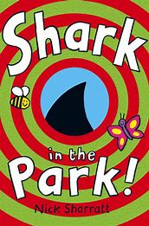  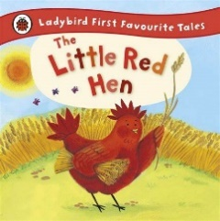  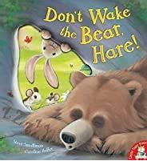 | 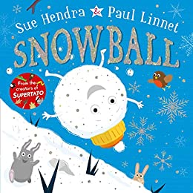  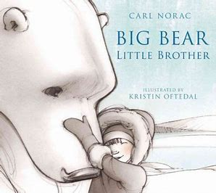  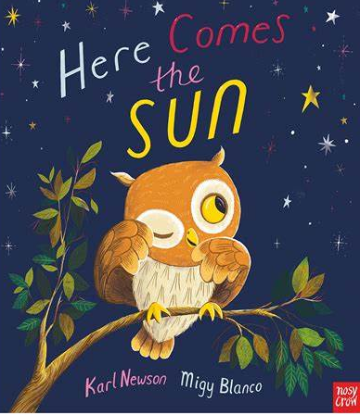 | 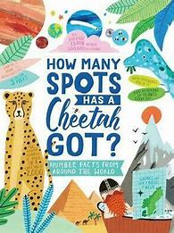  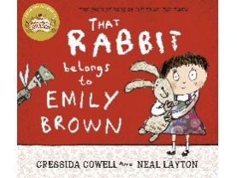  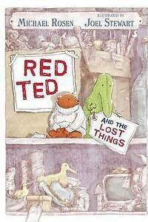 | 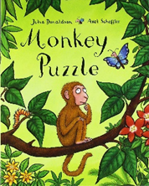  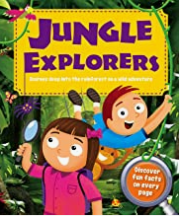  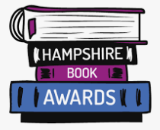 | 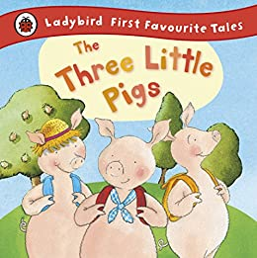 | 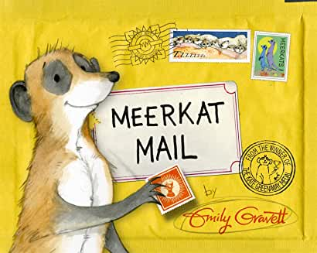  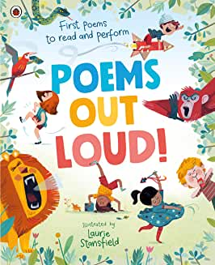  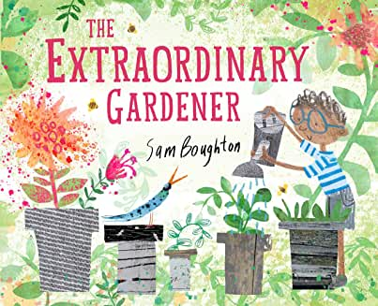
Writing | 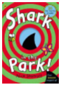  Writing to entertain: ‘through the telescope’.  Form: Descriptive writing  Outcome: Description of our school  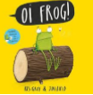  Form 1: Sentence writing using rhyming words  Form 2: Descriptive sentences  Purpose: Writing to entertain  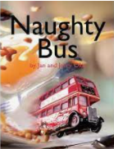  Form 1: Rhyming sentences  Form 2: Short narrative  Purpose: Writing to entertain | 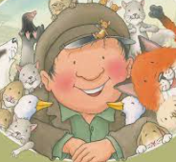  Form 1: setting description  Outcome: descriptive sentences about the Park  Form 2: Letters  Outcome: Writing a letter to Percy  Purpose: Writing to entertain  Form: Instructional writing  Outcome 2: Percy’s Park instructions  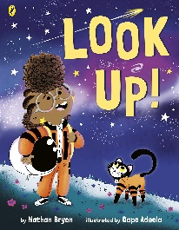  Purpose: Writing to inform  Form:  Outcome:  Purpose: | 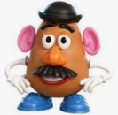    Mr Potato Head’s big adventure  Form: short adventure narrative, animated by Chatter pix.  Purpose: Writing to entertain  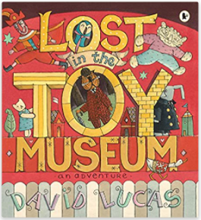  The Toy museum:  Form 1: Explanation on how a toy works  Outcome: Museum tour guides afternoon  Purpose: writing to explain | 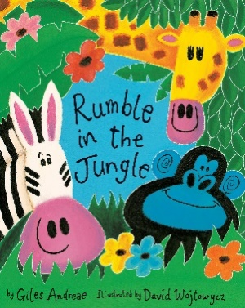  Form: Speaking and listening Outcome: Performance poetry  Purpose: Writing to entertain  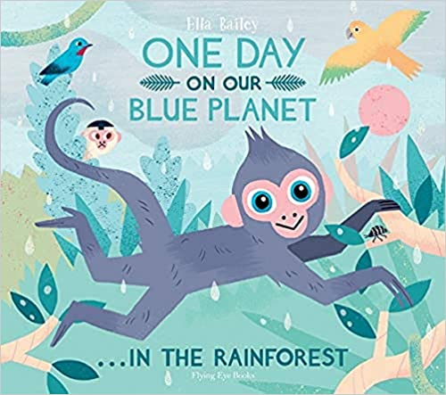  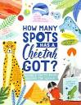  Form: Information page  Outcome: Rainforest fact page  Purpose: Writing to inform | 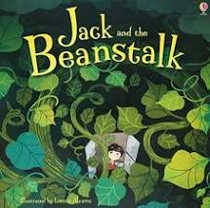  Form 1: Letters  Outcome: Letter from the Giant to Jack  Form 2: Story re-tell  Purpose: Writing to entertain  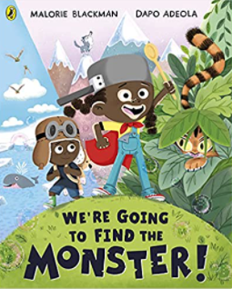  Form 1: Explanation  Outcome: How to ‘Monster search guides’  Purpose: Writing to explain  Form 1: Adventure stories  Purpose: Writing to | 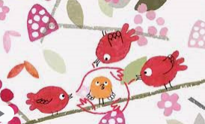  Whistleless Media clip  Form 1: setting descriptions  Form 2: Narrative  Purpose: Writing to entertain  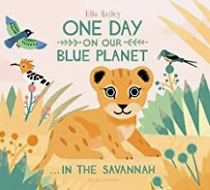  Form: Meerkat fact files  Purpose: Writing to inform
curriculum writing and linked text drivers | 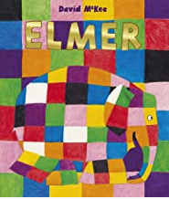  Elmer – No Outsiders PSHE | Description of one of the seasons – Geography and science  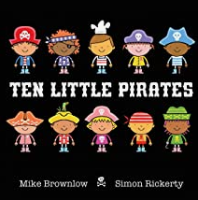  Ten little pirates – No Outsiders PSHE | Write about changes since I was a baby – Science  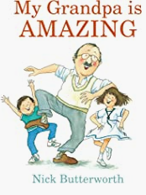  My Grandpa is amazing – No Outsiders PSHE | Postcard of a trip to the Rainforest – Geography  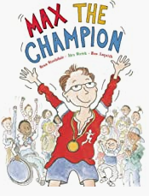  Max the Champion – No Outsiders PSHE | What changes were made after the Great Fire of London?  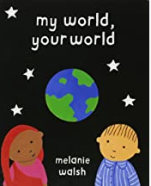  My world, your world – No Outsiders PSHE | Description of what you would pack for Sunny for a new place – Geography  Description of the function of different parts of a plant – science

Writing progression for Year 1: Please use this to inform your objectives for teaching across the year
Composition and effect | Sentence structure | Structure and organisation | Spelling strategies | Vocab, Grammar and punctuation
• Say out loud what they are going to write about  • Sect basic ideas and content linked to the purpose of a task  • Discuss what they have written with the teacher or other pupils  • Re-read what they have written to check that it makes sense  • Use simple word choice that helps to convey information and ideas, e.g. story or topic related vocabulary  • Use simple prepositions | ` ` • Compose a sentence orally before writing it  • Write a simple sentence starting with a personal pronoun  • Write a simple sentence starting with a noun/proper noun  • Write a simple sentence with straightforward subject/ verb agreement  • Write reliably formed simple and compound sentences | • Show an awareness that ideas can be organised into a sequence  • Sequence sentences to form short narratives  • Begin to organise ideas/events using simple time related words, numbers, ordering of pictures/captions | • Spell words containing each of the 40+ phonemes already taught  • Spell the days of the week • Use –ing and –ed, where no change is needed in the spelling of root words  • Begin to spell words using contracted forms  • Use the spelling rule for adding –s or –es as the plural marker for nouns and the third person singular marker for verbs  • Use the prefix –un  • Add prefixes and suffixes using –er and –est where no change is needed in the spelling of root words  Ongoing:  Write from memory simple sentences, dictated by the teacher, that include words and punctuation taught so far  Spell common exception words that have been taught | • Leave spaces between words  • Use capital letter for names  • Use capital letter for the personal pronoun ‘I’  • Use a capital letter for days of the week  • Begin to punctuate sentences using a capital letter and a full stop  • Begin to punctuate sentences using a question mark  • Begin to punctuate sentences using an exclamation mark  • Join words using ‘and’  • Join clauses using ‘and’ • Use simple noun phrases (adjective + noun)

