
English overview: Year 2 – 2022-2023
Year 2 Overview | Autumn 1 | Autumn 2 | Spring 1 | Spring 2 | Summer 1 | Summer 2
Reading | Guided reading text – Tidy by Emily Gravett  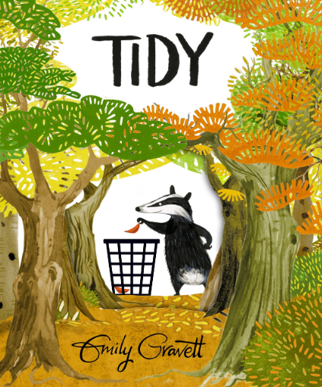 | Guided reading text – Grandad’s Secret Giant  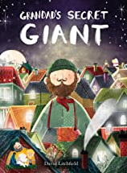  Badger books | Guided reading text – The Tin Forest and Into the Forest  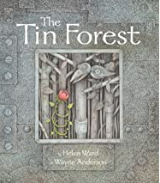  Badger books | Guided reading text – poetry/comprehension (prep for SATs)/  The Night Gardener  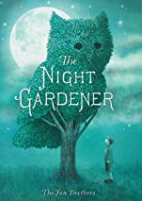  Book week – themed week of reading  Badger books | Guided reading text – Comprehension (SATs prep)/Reading SATs Papers  Badger books | Guided reading text –  Leon and the Place between  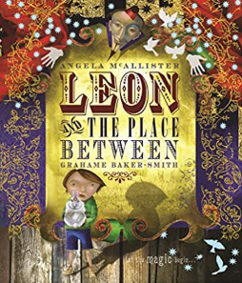  Badger books
Writing | Tidy by Emily Gravett  Form 1: Re-telling of the story (oral)  Form 2: Character description  Form 3: Setting description  Purpose: Writing to entertain  Form 4: Instructions  Purpose: Writing to inform  The Three Billy Goats  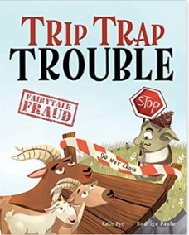  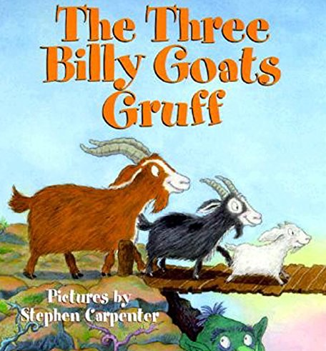  Form 1: Character descriptions  Form 2: Alternative endings retell  Purpose: Writing to entertain | A Walk in London Fiction  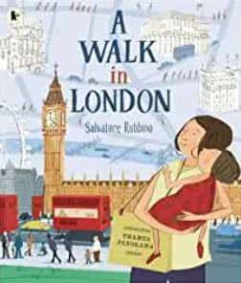  Form 1: Narrative re-tell  Form 2: Letters to the Queen  Purpose: Writing to entertain  The Proudest Blue  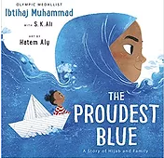  Form 1: Series of Diaries  Purpose: Writing to entertain | In the Night Zoo (literacy shed clip)  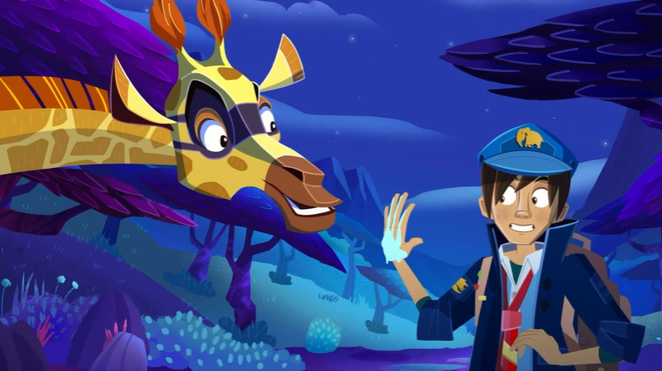  Form 1: Animal descriptions  Dinosaurs from Head to Tail by Stacey Rodderick  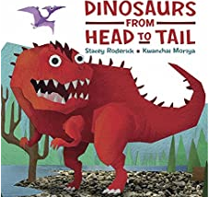  Form 1: Non – Fiction – Information Text Series of Top Trumps cards  Lost and Found by Oliver Jeffers Narratives  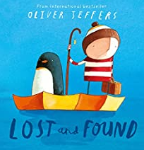  Form: Alternative narrative  Purpose: Writing to entertain | 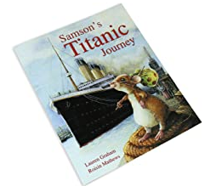  Samson’s Titanic Journey by Lauren Graham  Form 1: Samson’s diaries  Form 2: Non-chronological report  Form 3: Recount of trip to Seacity  Poetry –  Poetry – Pink by Christina Rossetti  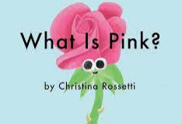  Form 1: Poetry writing  Form 2: Oral rehearsal/ performance | How to Catch a Star by Oliver Jeffers  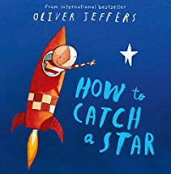Form: Explanations  Purpose: Writing to explain and inform  The Darkest Dark by Chris Hadfield  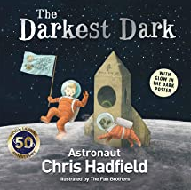  Form 1: Letters  Form 2: Narratives | Prince Veera – Stories from other cultures  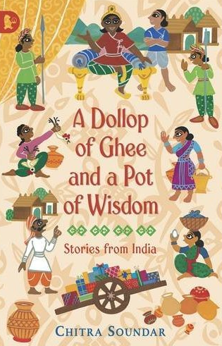  Form: Narrative – A case for Prince Veera to solve  Purpose: Writing to entertain  Leon and the Place between  Form 1: Instructions  Form 2: Fantasy Narrative  Letters
Writing in topic/Science | Science writing – create a plant information guide | Instructions – How to make a vegetable skewer  Retelling the journey of Christmas Story | Series of top trumps cards for animals/plants in the food chain | Retelling of Palm Sunday  Science writing linked to forces | Instructions for moon buggies | Explanation of Weather Patterns

Writing progression for Year 2: Please use this to inform your objectives for teaching across the year
Composition and effect | Sentence structure | Structure and organisation | Spelling strategies | Vocab, Grammar and punctuation
• Consider what they are going to write before beginning by planning or saying out loud what they are going to write about | • Write statements  • Write questions (beginning with who/ what/ when/ where/ how etc.)  • Write exclamatory sentences starting with ‘what’ or ‘how’  • Write commands using the imperative form of a verb | • Consider what they are going to write before beginning by encapsulating what they want to say, sentence by sentence  • Use brief opening and ending  • Sequence ideas appropriately  • Link related sentences through the use of pronouns and adverbials where appropriate | • Spell by segmenting spoken words into phonemes and represent these by graphemes, spelling many correctly  • Spell by learning new ways of spelling phonemes for which one or more spellings are already known  • Spell common homophones  • Distinguish between homophones and near-homophones  • Add suffixes to spell longer words, including –ly • Add suffixes to spell longer words, including –ful, –less (to create adjectives)  • Add suffixes to spell longer words –ment, –ness • Use the possessive apostrophe (singular)  • Spell more words with contracted forms  Ongoing:  Write from memory simple sentences, dictated by the teacher, that include words and punctuation taught so far  Spell common exception words that have been taught | • Use capital letters, full stops, question marks and exclamation to demarcate sentences  • Use commas to separate items in a list  • Use apostrophes to mark where letters are missing in spelling  • Use apostrophes to mark singular possession in nouns  • Use coordinating conjunctions (or/and/but)  • Use subordinating conjunctions (when/ if/ that /because)  • Write expanded noun phrases to describe and specify  • Use the present and past tenses correctly and consistently  • Use the progressive form correctly and consistently e.g. he was shouting.  • Use –ly to turn adjectives into adverbs – slow/ slowly • Use the suffixes er, -est, in adjectives

