
2
English overview: Year 4 – 2022-2023
 | Autumn 1 | Autumn 2 | Spring 1 | Spring 2 | Summer 1 | Summer 2
Reading | Guided reading text –  The Lost Happy Endings  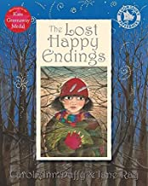  Badger books reading scheme | Guided reading text  Cinnamon (stories from other cultures)  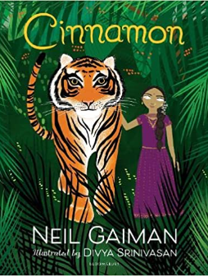  Badger books reading scheme | Guided reading text  Non-fiction text  Whales  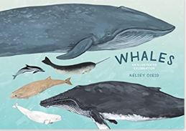  Hampshire information book award (Non Fiction) | Guided reading text  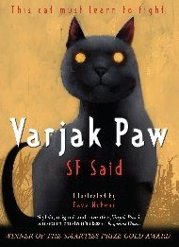  Varjak Paw (Stories from other cultures)  Badger books reading scheme | Guided reading text  Varmints Picture book study (3 weeks)  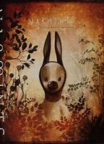  Badger books reading scheme | Guided reading text  Arthur and the Golden Rope (Mythical)  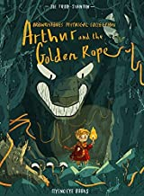  Guided reading text  The Lost Words poetry study  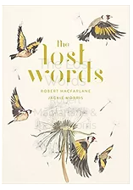
Writing | The lost happy endings  Form 1: Character description  Form 2: Setting description  Form 3: Spooky  narrative  Purpose: Writing to entertain Form 4: Instructions  Purpose: Writing to inform  Until I met Dudley  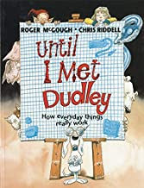  Form: Explanation texts  Purpose: Writing to explain | The Wild Robot  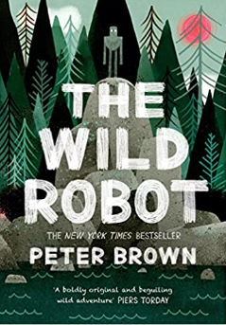  Form 1: Suspense writing  Form 2: Poetry  Purpose: Writing to entertain  Form 3: Robot Roz’s Survival guide  Purpose:: Writing to inform  Cinnamon  Form 1: Diaries  Form 2: Narrative  Purpose: Writing to entertain | The Whale  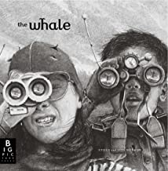  Form 1: Conservation report on whales/ wildlife  Form 2: Conservation poetry  Adrift  Literacy shed clip  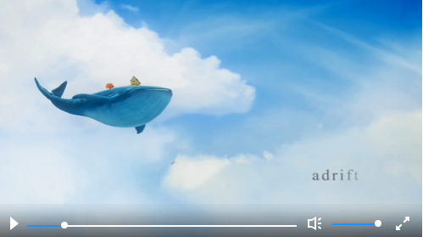  Form 1: fantasy narrative re-tell  Purpose: Writing to entertain  The Lighthouse video  Literacy shed clip  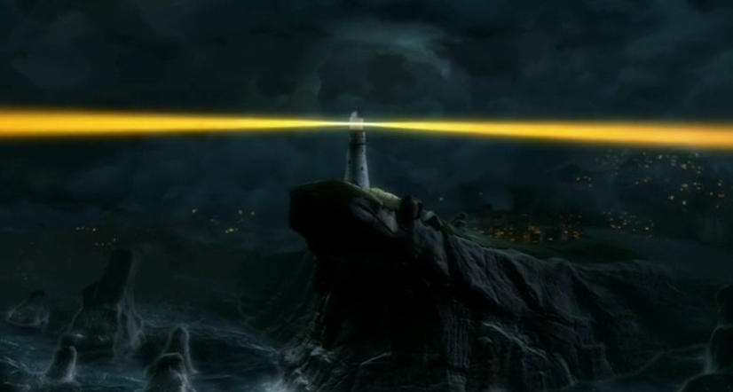  Form 1: Series of diaries  Form 2: Newspaper article  Purpose: Writing to entertain | Emmanuel’s dream  Lyrical prose  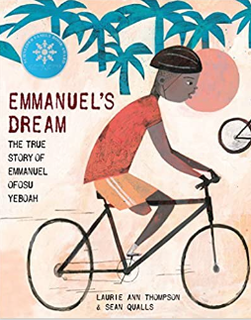  Scarlett – Literacy Shed clip  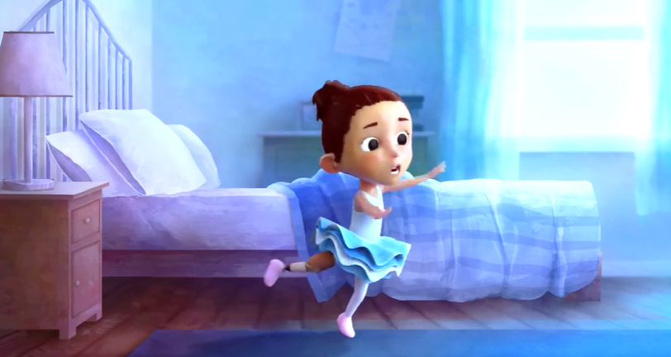  Form 1: series of journals Form 2: Performance poetry linked to inspirational story  Varjak Paw  Form 1: Series of letters  Form 2: Newspaper report about vanishings  Form 3: News report for cats disappearances  Purpose: Writing to entertain | There’s a boy at the back of the class  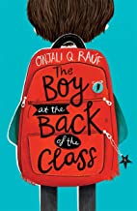  Form 1: Descriptive writing – setting and character  Form 2: Writing in role linked to refugees as letters  Purpose: Writing to entertain  Form 2: Formal letter to Government  Purpose: Writing to persuade  Malala’s Magic Pencil  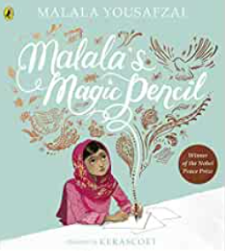  Form 1: Malala’s diary  Purpose: Writing to entertain  Form 2: Campaign speech  Purpose: Writing to persuade | The True Story  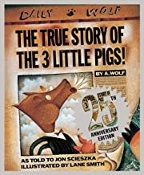  Form 1: Alternative endings narrative  Form 2: Playscript  Purpose: Writing to entertain  The Lost Words  Form 1: Setting descriptions  Form 2: Performance poetry
curriculum text drivers | Chronological explanation of the digestive system  Narrative journey of a leaf on the river Itchen | Anglo Saxons survival guides | Non-chronological report on Russia | Vicious Vikings explorers guide | Persuasive tour guides on our City | Tudor Survival Guide
curriculum text drivers | Dogs don’t do ballet (self confidence)  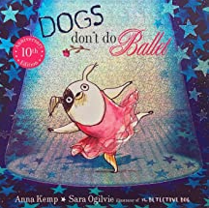 | King and King  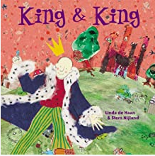 | The Way back home  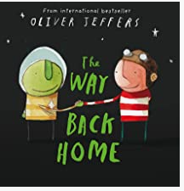 | The flower (choices)  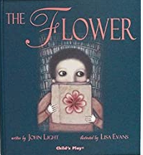 | Red: A crayon’s story (self confidence)  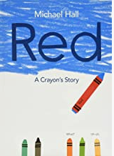

Writing progression for Year 4: Please use this to inform your objectives for teaching across the year
Composition and effect Ongoing objectives |  | Sentence structure | Structure and organisation | Spelling strategies | Vocab, Grammar and punctuation
• Discuss writing similar to that which they are planning to write in order to understand and learn from its structure, vocabulary and grammar  • Consistently maintain the viewpoint of writing (for example, word choice indicates child’s viewpoint on a character or an issue)  • Use a varied and rich vocabulary  • Expand description or detail in both narrative and non-narrative through an appropriate and precise range of vocabulary  • Use figurative language such as similes, alliteration to build a picture in the reader’s head | Make their writing clear in purpose  Plan their writing by discussing writing similar to that which they are planning to write in order to understand and learn from its structure, vocabulary and grammar  Plan their writing by discussing and recording ideas  In narratives, create settings, characters and plot  Evaluate and edit by assessing the effectiveness of their own and others’ writing and suggesting improvements | • Compose and rehearse sentences orally (including dialogue)  • Use an increasing range of sentence length and structure  Ongoing:  Extend the range of sentences with more than one clause by using a wider range of conjunctions, including when, if, because, although (complex) | • Use simple organisational devices in non-narrative material  • Signal openings and closings clearly and develop these well  • Produce internally coherent paragraphs in logical sequence e.g. using topic sentences with main ideas supported by subsequent sentences  • Choose nouns or pronouns appropriately for clarity and cohesion and to avoid repetition  • Use conjunctions, adverbs and prepositions to express time and cause for cohesion  Ongoing:  Organise paragraphs around a theme | • Use further prefixes and suffixes and understand how to add them (English Appendix 1: see doubling rules, changes to in-, re-, sub-, inter-, super-, auto-, anti-, -ation, changes to –ly, -sure, -ture/-cher, -ous plus necessary changes, -tion/-cian/-sion/-ssion)  • Spell further homophones  • Place the possessive apostrophe accurately in words with regular plurals e.g. boys’, girls’ and in words with irregular plurals e.g. children’s  • Plural nouns of words ending in ‘o’  Ongoing:  Use the first two -three letters of a word to check its spelling in a dictionary Spell words that are often misspelt (English Appendix 1) Write from memory simple sentences, dictated by the teacher, that include words and punctuation taught so far | • Use inverted commas and other punctuation to indicate direct speech e.g. a comma after the reporting clause; end punctuation within inverted commas: The conductor shouted, “Sit down!”  • Use noun phrases expanded by the addition of modifying adjectives, nouns and preposition phrases e.g. the strict maths teacher with curly hair  • Understand the difference between plural and possessive –s  • Use Standard English forms for verb inflections instead of local spoken forms  • Use fronted adverbials followed by a comma • Use the present perfect form of verbs in contrast to the simple past tense  Ongoing:  Proof-read for spelling and punctuation errors Indicate possession by using the possessive apostrophe with plural nouns  Propose changes to grammar and vocabulary to improve consistency, including the accurate use of pronouns in sentences

