Year 5 overview 2022-2023
Year 5 Overview | Autumn 1 | Autumn 2 | Spring 1 | Spring 2 | Summer 1 | Summer 2
Reading | Traditional tales - Neil Gaiman Hansel and Gretel (3 weeks)  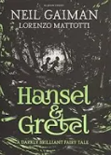 |  | Alex Rider – Stormbreaker (4 weeks)    Badger books (3 weeks) | Badger books (2 weeks) | A Story like the wind  (2 weeks)  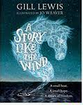  The Journey by Francesca Sanna (2 weeks)  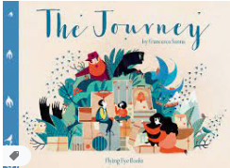  Badger books (2 weeks) | Origin of Species (2 weeks)  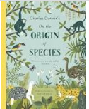  The Natural world section of poems (3 weeks)  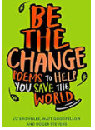
  Tutankhamun non-fiction text study (3 weeks)
  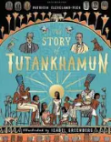
  Hampshire Illustrated book award (1 week)
  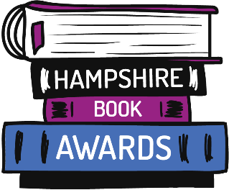
  Badger books (3 weeks
  Wonder by RJ Palacio (3 weeks)
  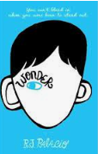
  Poetry week – author visit and study (1 week)
Writing | 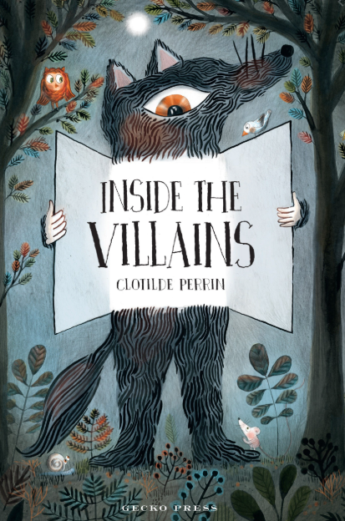  Inside the Villains (4 weeks)  Form 1: Character and setting descriptions  Form 2: Alternative ending narrative (Hansel and Gretel)  Form 3: Character Personality cards (Hansel and Gretel)  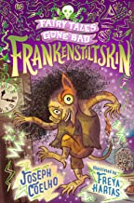  Frankenstiltskin (2 weeks) – Poetry  Form 1: poetry performance  Form 1: alternative ending retell linked to Fairytale from Inside the Villains | 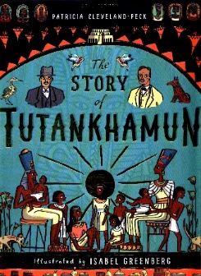  The Story of Tutankhamun  Form 1: Chronological report of Carter’s discovery (3 weeks)  Purpose: Writing to inform  Form 2: Newspaper article with witness accounts from different story sections (3 weeks)  Purpose: Writing to entertain  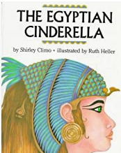  The Egyptian Cinderella  Form 1: journal writing  Form 2: Persuasive speech  Purpose: Writing to entertain/persuade | 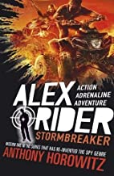  Storm breaker  Form 1: Explanation text (Blueprints for a new spy gadget)  Purpose: Writing to explain  Form 2: Persuasive advert for gadget investment  Purpose: Writing to persuade    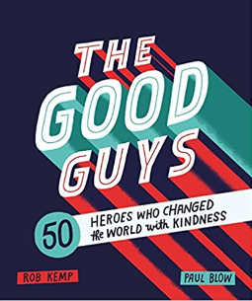  The Good Guys  Megacity (Literacy shed clip  Form 1: Series of short journal entries  Purpose: Writing to entertain Form 2: Letter of nomination to World Kindness Awards 2022  Purpose: Writing to persuade | 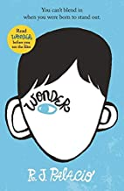  Wonder (Book) (4 weeks)  Form 1: Series of diaries (2 weeks)  Form 2: Auggie’s Speech (2 weeks)  Purpose: Writing to entertain/persuade  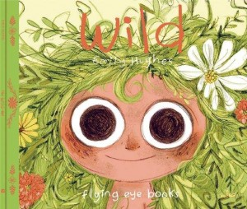  Wild (2 weeks)  Picture book study  Form 1: Alternative ending narrative  Purpose:: Writing to entertain | 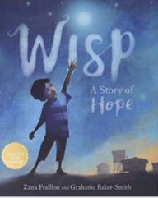  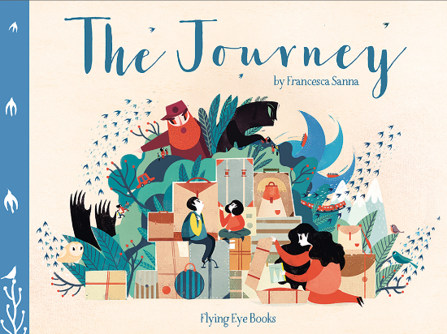  Wisp and The Journey (3 week)  Form 1: Monologues  Form 2: Poetry  Purpose: Writing to entertain  Brightstorm (3 weeks)  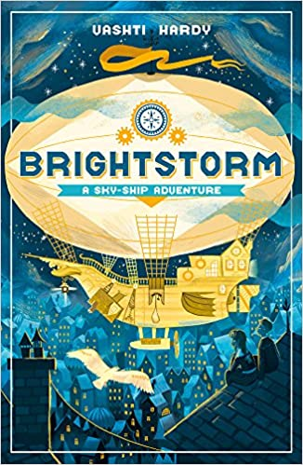  Descriptive writing  Skyship design – explanation  Newspaper article (linked to page 13) | 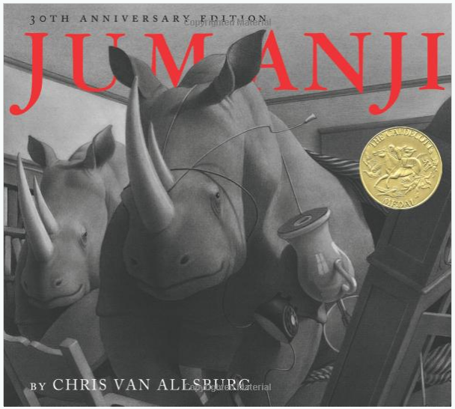Jumanji – narrative  (3 weeks)  Form 1: Series of moments  narrative writing  Form 2: Survival guide to play the game  Purpose:: Writing to entertain/inform  Last – Story of a white rhino  (4 weeks)  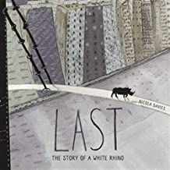  Form 1: Non Chronological reports  Form 2: Persuasive speech on captivity  Form 3: Ballad poems (poems with a powerful message) similar to song writing  Purpose: Writing to entertain and persaude
Writing in topic/Science | Writing in role – the life cycle of a frog (Science)  Correspondence to the President (Topic) | Ancient Egypt mummification step by step guide | A travel guide to the Caribbean |  | Victorian diaries | Rainforest survival guides and field notes
PSHE linked

Writing progression for Year 5: Please use this to inform your objectives for teaching across the year
Composition and effect Ongoing objectives |  | Sentence structure | Structure and organisation | Spelling strategies | Vocab, Grammar and punctuation
• Choose the appropriate register for the audience and purpose (formal or informal)  • Establish and generally maintain viewpoint  • Balance content, e.g. between action/ description/dialogue, fact and comment  • Select appropriate grammar and vocabulary, understanding how such choices can change and enhance meaning  • Use expanded noun phrases to convey complicated information concisely  • Use figurative language such as similes, alliteration, metaphors and personification in poetry  • Edit sentences by either expanding or reducing for meaning and effect | Note and develop initial ideas, drawing on reading and research where necessary  Identify audience for, and purpose of, the writing  Select the appropriate form and use other  similar writing as models for their own  In narratives, describe settings, characters and atmosphere  Evaluate and edit by assessing the effectiveness of their own and others’ writing  Propose changes to vocabulary, grammar and punctuation to enhance effects and clarify meaning | • Make deliberate choices of sentence length and structure for impact on the reader  • Use fronted prepositional phrases for greater effect e.g. Throughout the stormy winter … Far beneath the frozen soil …  • Choose the appropriate register for the language of speech within writing e.g. colloquial language within dialogue, quotes in reports  Ongoing:  Use a wide range of clause structures, sometimes varying their position within the sentence | • Produce internally coherent paragraphs in logical sequence e.g. posing rhetorical questions which are answered in the main paragraph with main ideas elaborated by subsequent sentences  • Link ideas across paragraphs using adverbials of time (later), place (nearby) number (secondly)  • Link ideas across paragraphs through tense choice (he had seen her before)  • Use a wide range of devices to build cohesion within paragraphs  Ongoing:  Use further organisational and presentational devices to structure text and to guide the reader e.g. headings, bullet points, underlining, columns, tables | • Use knowledge of morphology and etymology in spelling and understand that the spelling of some words needs to be learnt specifically, as listed in English Appendix 1 (-cious/-tious, -cial/-tial, -ible/-able, –ent/-ant rules and exceptions, -fer + suffix, i before e except after c plus exceptions, -ough- words)  • Use further prefixes and suffixes and understand the guidance for adding them e.g. - dis-’, ‘de-’, ‘mis-’, ‘over-’ and ‘re-’ • Spell some words with ‘silent’ letters  • Continue to distinguish between homophones and other words which are often confused  Ongoing:  Use the first three or four letters of a word to check spelling, meaning or both of these in a dictionary  Use a thesaurus | • Use commas to clarify meaning or avoid ambiguity in writing  • Use relative clauses beginning with who, which, where, when, whose, that  • Convert nouns or adjectives into verbs using ‘-ate’, ‘-ise’ or ‘-ify’  • Use modal verbs or adverbs to indicate degrees of possibility  Ongoing:  Proof-read for spelling and punctuation errors Ensure the consistent and correct use of tense throughout a piece of writing Use the perfect form of verbs to mark relationships of time and cause  Use correct subject and verb agreement when using singular and plural  Use brackets, dashes or commas to indicate parenthesis  Use a colon to introduce a list  Use semi colons, colons or dashes to mark boundaries between independent clauses

