
2
English overview: Year 6 – 2022-2023
 | Autumn 1 | Autumn 2 | Spring 1 | Spring 2 | Summer 1 | Summer 2
Reading | 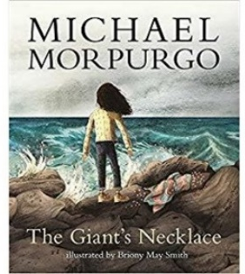  The Giant’s Necklace  (3 weeks)  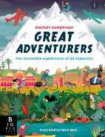  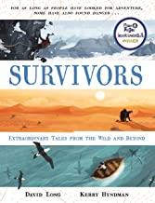  Survivors / Great Adventurers  (3 weeks) | 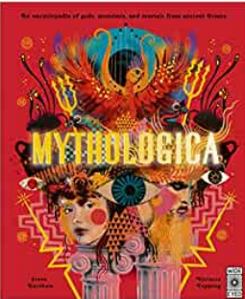  Mythologica  (3 weeks)  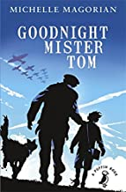  Goodnight Mr Tom  (4 weeks) | 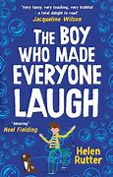  The boy who made everyone laugh  (3 weeks)  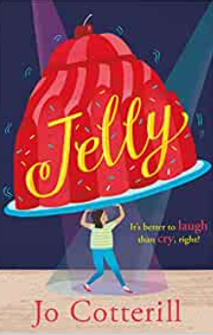  Jelly (3 weeks) | 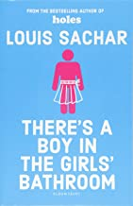  There’s a boy in the girls’ bathroom  (3 weeks)  Badger Learning | 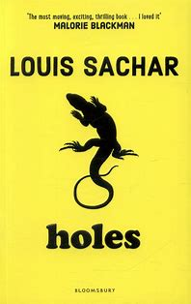  Holes By Louis Sachar (3 weeks)  Badger Learning | 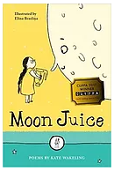  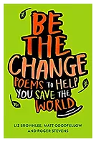  Poetry  Moon juice and Be the Change  (6 weeks)
Writing | 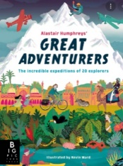  Survivors / Great Adventurers (3 weeks)  Form 1: Character and setting description  Purpose: Writing to entertain  Form 2: Survival guide – (2 weeks)  Purpose: Writing to explain and entertain    Alma (3 weeks)  Form 1: Film review for the ‘Fantastic Fest’ awards  in Spain  Form 2: Writing in role  Outcome: Diary extracts from different moments  Purpose: Writing to entertain | Mythologica (2 weeks)  Form 1: Non-chronological report  Outcome: Greek God/Goddess Social media profile page  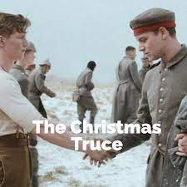  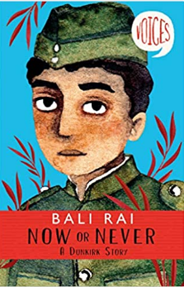  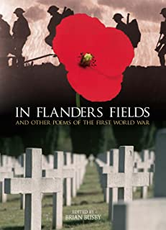  (4 weeks)  Form 1: Series of letters  Purpose: Writing to entertain  Outcome: series of tea-stained letters from the trenches  Form 2: Retelling of one of the stories as a graphic novel linked to ‘Now or Never’  Form 3: War poetry  Purpose: Writing to entertain | 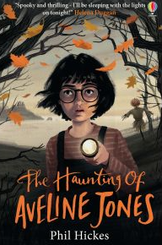  The Haunting of Aveline Jones (4 weeks)  Francis Brandywine (Literacy shed video)  Form 1: Non-chronological  missing person’s report  Newspaper report    The Island (3 weeks)  Form 1: Debate  Outcome: Article debate  Purpose: writing to discuss/persuade  Form 2: Viewpoint writing  Outcome: Journals from different perspectives  Purpose: Writing to entertain | 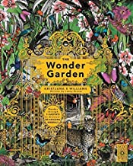  The Wonder Garden (3 weeks)  Form 1: Non-chronological report – field notes study  Outcome: Writing to inform  Form 2: Persuasive piece on environmental health  Outcome: Article on Earth’s pollutants  Purpose: Writing to discuss and explain  There’s a boy in the girls’ bathroom (3 weeks)  Form 1: Descriptive writing  Outcome: Character and setting descriptions  Form 2: Writing in role  Outcome: Diary series as Bradley Chalker  Purpose: Writing to entertain | 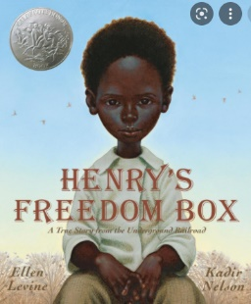  Henry’s Freedom Box  (3 weeks)  Form 1: Henry  Form 2: emotive speech  Purpose: Writing to entertain  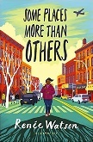  (3 weeks)  Form 1: writing in role  School suitcase project – memory letter  Form 2: Interview  Purpose: Writing to entertain | 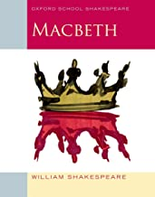  Macbeth (4 weeks)  Form 1: Narrative – character and setting description  Outcome: Character description of the witches and setting description of the Heathland  Form 2: Persuasive speech  Outcome: Macbeth’s speech  Purpose: Writing to entertain  Form: Poetry  Outcome: Poetry slam performance  Purpose: Writing to entertain
curriculum text drivers | Science – Light  Create an encyclopaedia entry about different forms of light | Stages of Evolution  Moth An Evolution Story  Create own evolution narrative  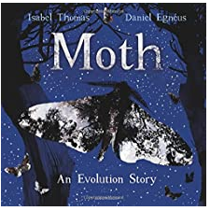 | Baghdad Mayans  Travel guide | Animals including humans Fantastic Beasts – field notes on an animal (1 animal)  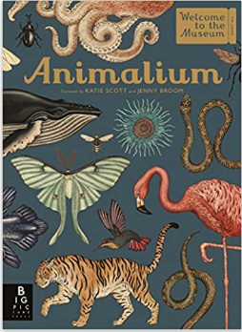 | All living things (Science)  Classification guide  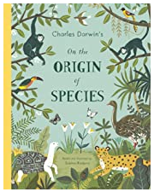
curriculum text drivers | 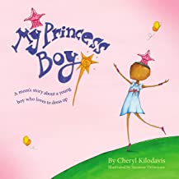  My Princess Boy – No Outsiders PSHE | 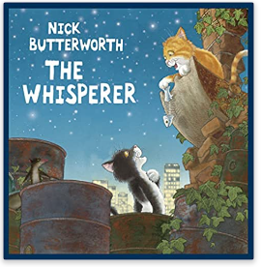  The whisperer – No Outsiders PSHE | The Island – No Outsiders PSHE | 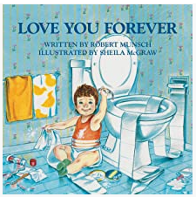  Love you forever – No Outsiders PSHE | 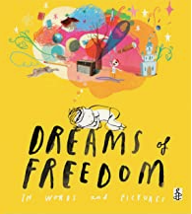  Dreams of freedom Equality Act – No Outsiders PSHE |   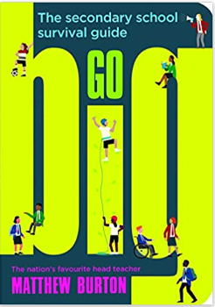  Learning for life PSHE

Writing progression for Year 6: Please use this to inform your objectives for teaching across the year
Composition and effect Ongoing objectives |  | Sentence structure | Structure and organisation | Spelling strategies | Vocab, Grammar and punctuation
• Use adverbs, prepositional phrases and expanded noun phrases effectively for qualification and precision  • Understand and apply the difference between vocabulary typical of informal speech and vocabulary appropriate for formal speech and writing e.g. find out/ discover; find out/ request; go in/ enter  • Integrate dialogue to convey character and advance the action  • Use figurative language such as similes, alliteration, metaphors and personification in a range of writing  • Select verb forms for meaning and effect e.g. deliberate change of tense  • Manage shifts in levels of formality within a text  • Select synonyms accurately for effect rather than as an alternative for an original word | Note and develop initial ideas, drawing on reading and research where necessary  Identify audience for, and purpose of, the writing  Select the appropriate form and use other  similar writing as models for their own  In narratives, describe settings, characters and atmosphere  Evaluate and edit by assessing the effectiveness of their own and others’ writing  Propose changes to vocabulary, grammar and punctuation to enhance effects and clarify meaning | • Use the passive to affect the presentation of information in a sentence e.g. I broke the window in the greenhouse / the window in the greenhouse was broken  • Use the structures typical of informal speech e.g. the use of question tags: He’s your friend, isn’t he?  • Use the structures appropriate for formal speech and writing e.g. subjunctive forms such as If I were or Were they to come  Ongoing:  Use a wide range of clause structures, sometimes varying their position within the sentence | • Draft and write by using a wide range of devices to build cohesion within paragraphs  • Link ideas across paragraphs using a wider range of cohesive devices e.g. repetition of a word or phrase, grammatical connections (tense choice/ adverbials) and ellipsis  Ongoing:  Use further organisational and presentational devices to structure text and to guide the reader e.g. headings, bullet points, underlining, columns, tables | • Recognise how words are related by meaning as synonyms and antonyms  Ongoing:  Use the first three or four letters of a word to check spelling, meaning or both of these in a dictionary  Use a thesaurus | • Use relative clauses beginning with who, which, where, when, whose, that or with an implied (i.e. omitted) relative pronoun  • Use a semi colon within lists  • Use hyphens to avoid ambiguity  • Use modal verbs or adverbs to indicate degrees of possibility  • Punctuate bullet points consistently  Ongoing:  Proof-read for spelling and punctuation errors Ensure the consistent and correct use of tense throughout a piece of writing Use the perfect form of verbs to mark relationships of time and cause  Use correct subject and verb agreement when using singular and plural  Use brackets, dashes or commas to indicate parenthesis  Use a colon to introduce a list  Use semi colons, colons or dashes to mark boundaries between independent clauses

