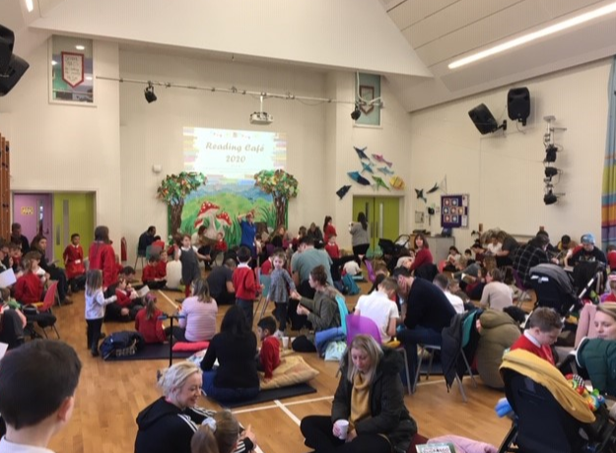

English at The Crescent Primary School
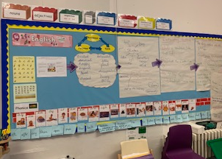
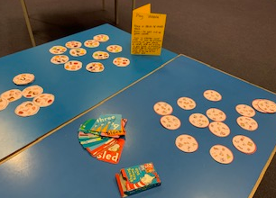
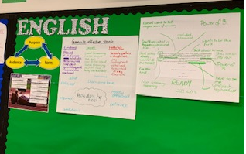

This guidance booklet will cover:
The vision for English
Phonics
Spelling
Reading
Writing
Assessment
Progression
Glossary of terminology used in school
The vision for English:

At the Crescent Primary, English is a core foundation across all of our curriculum subjects and reading and writing skills are applied in a range of contexts. In line with our REACH school values (resilience, evaluative, ask questions, challenge and help one another), opportunities to achieve these values are embedded within our English curriculum. We want our children to develop a love of language and this is vital to develop their ability to enquire, respond and express themselves. We seek for our children to ask questions and become evaluative of what they are accessing and creating. We aspire for our children to engage with our curriculum with enjoyment and wonder.
We believe reading underpins all aspects of the curriculum. High quality teaching of reading is fundamental to our practise; therefore, independent application of reading is widely embedded across the curriculum to allow learners to enquire, discover and grow curious minds. We teach reading through a blend of whole class teaching and individual ability group texts which are progressive across all key stages. Throughout our curriculum, we focus on making sure that all children are fluent in the 8 skills of a reader: Making links when we read; Making predictions; Visualising what we read; Making inferences; Noticing if it doesn't make sense; Having strategies to 'fix' our reading if it doesn't make sense; Noticing new words and bringing all of our knowledge together! When children have mastered all of these eight skills, they will be confident, life-long readers! Most importantly, we value reading for pleasure – walk around our school and you will see our shared love of books in our classrooms, outdoor spaces (The Book Barn), our woodland library and from through the enthusiasm staff and pupils.

In writing, children follow a learning journey of skills progressions which leads to a specific and purposeful outcome. It is important for our pupil’s development that journeys offer links between taught units, lessons and year groups to ensure they are progressive and sequential. Our journeys are purposeful with audiences and varied forms of publications – often applied across the curriculum in other subjects. They begin with exploration and immersion of language and form, followed by application of grammar whilst practising their writing craft. Teachers will use assessment for learning throughout the journey to adapt and intervene to support and challenge pupils. Finally, opportunities to draft, produce and evaluate their writing, with editing and evaluation forming an on-going part of our craft as writers. Excitingly, children are always provided with an exciting way to publish and celebrate their final pieces as authors, which supports their confidence in themselves as authors.
In Phonics, we follow the Essential Letters and Sounds programme from the beginning of Reception. Essential Letters and Sounds is a phonics programme which consists of six phases. The programme builds progressively, beginning with learning the initial letter sounds and gradually building on these to blend and then read whole words. We believe that children learn to read more confidently when they have a picture to associate with a sound and this strategy is used throughout the school to help the children become fluent readers. The children will follow this programme throughout EYFS and Key Stage 1 and will use this as their basis for spelling throughout their school journey.
In spelling, we follow the No Nonsense Spelling scheme which is taught discretely on a daily basis across the year groups. Children are expected to apply taught skills across all writing opportunities, using dictionaries and thesauruses when necessary to promote independence. Weekly homework across the school is linked to Phonics (KS1) and Spelling (KS2). Spelling is a key focus across our curriculum and will form part of the verbal and written feedback given to support pupils. Our classrooms displays for vocabulary reflect new words that the children have learnt and their meanings.

Although English is taught through the strands of phonics, reading, writing, spelling and grammar, our ethos is to ensure learning encompasses all of these taught skills and children are given regular and purposeful opportunities to apply these across the curriculum.

Phonics at The Crescent Primary School
Phonics teaching begins in EYFS – Early Years Foundation Stage and is continued to be taught discretely across KS1. In Year 1 and 2, pupils will receive between 5 and 9 taught sessions of Phonics per week.
Phonics application occurs through continuous provision in Year R and 1 and through reading and writing opportunities across the curriculum. Regular phonics catch up intervention is planned for pupils across Key stage two who have not yet secured Phases 1-5 of Letters and Sounds independently. Further support is provided for pupils who have not secured the Government spelling list words for children by their class teacher and small group intervention work with the class LSA’s.
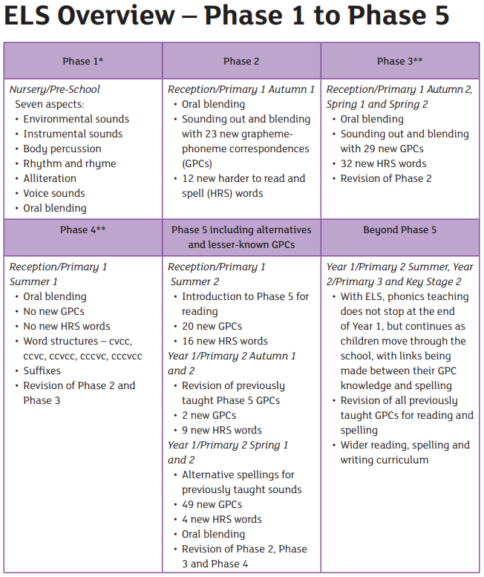

Phonics expectations for our school:
EYFS begin their phonics journey with Essential Letters and Sounds working from Phase 1 working up to the introduction of Phase 5. When ready, pupils will begin phase two; when pupils are moving away from mark making and beginning to form letters. Year R pupils are expected to have secured at least Phase 4 and be aware of Phase 5 phonics by the end of the academic year.
At the beginning of Year 1, pupils will begin at Phase 5, but will recap other phases where needed. At the end of Yea 1, pupils will practise all of the phonics sounds across phases 1-5 simultaneously. They will be tested at the end of this year with the standardised National phonics screening test. They will need to know all of the phonics sounds throughout Phases 1-5 securely. If they do not pass, they will have another chance to re-take the screening in Year 2.
Pupils in Year 2 revisit Phase 5 spellings. Children then follow the No Nonsense Spelling programme which is used across Key Stage two.
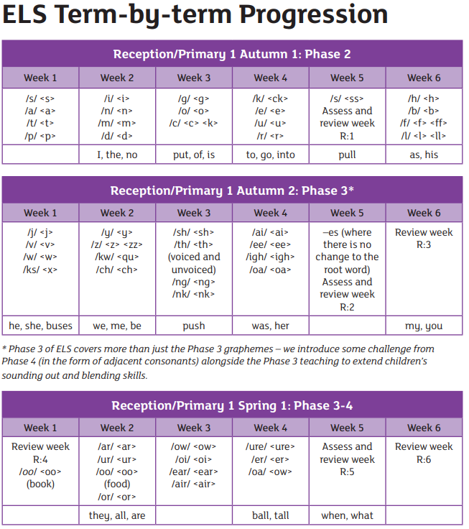

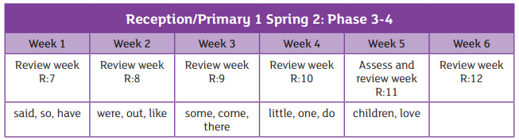
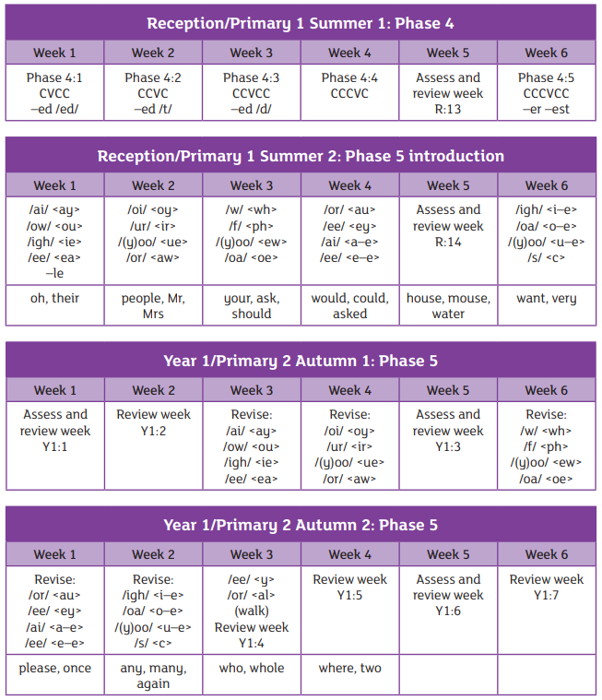

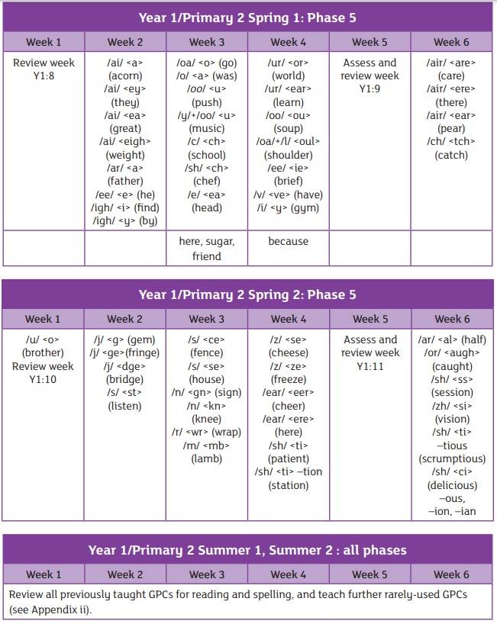

Structure of weekly taught phonics lessons using ESL:
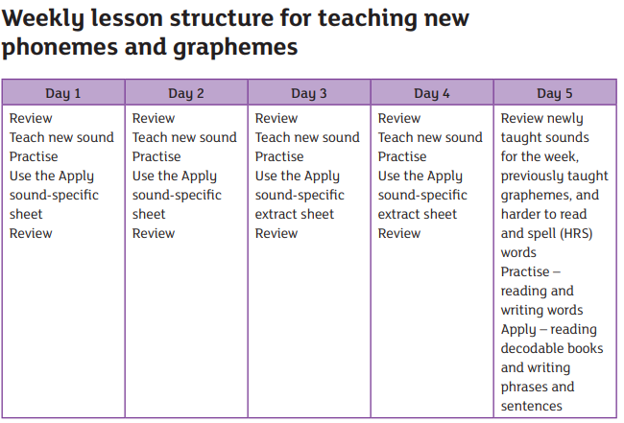
Concept of ESL:
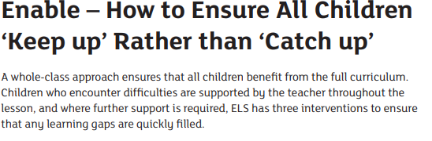

Letter join spelling support:
Across the school, pupils use the Letter Join programme which is a handwriting led pathway which uses the appropriate age-related phonetic and spelling lists for pupils. This allows pupils to embed their knowledge of spelling through practise, games and grammar sessions whilst focussing on handwriting. The scheme is used from EYFS to the end of Year 6.

Examples of children’s phonics learning in EYFS:
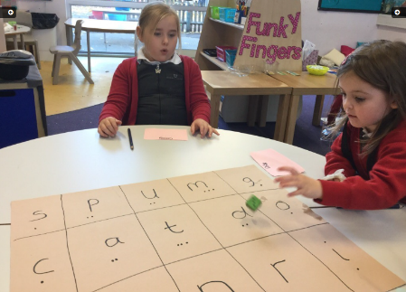
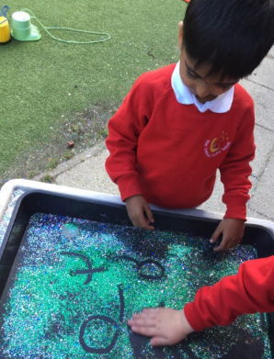
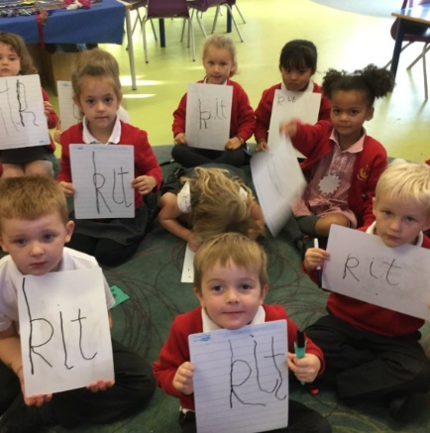

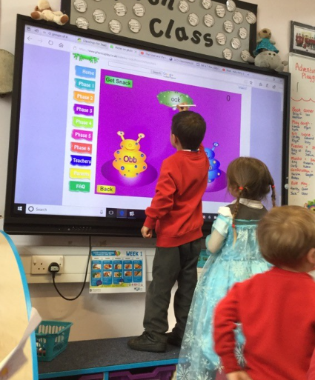
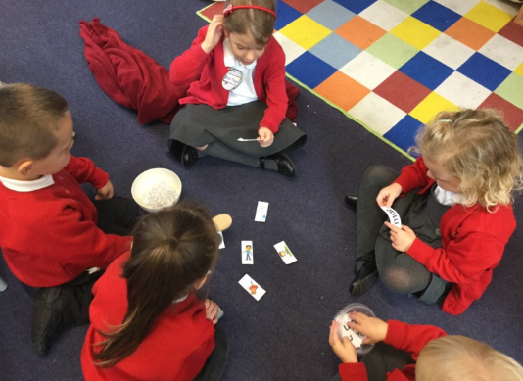
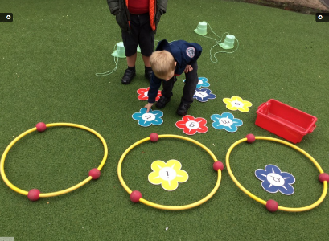

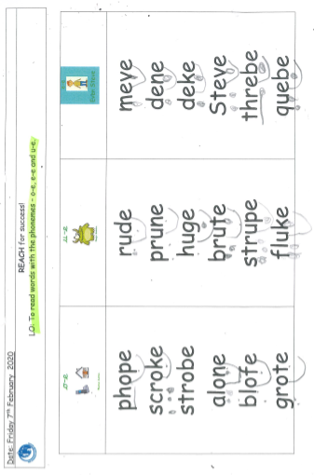

Examples of phonics learning in KS1:
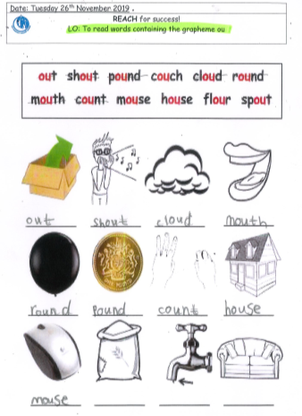

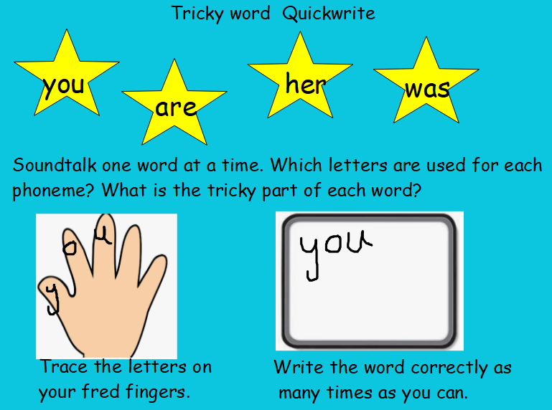

Further examples in KS1:
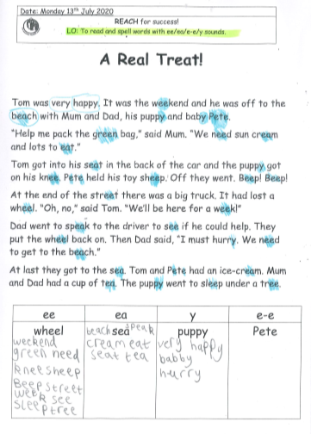

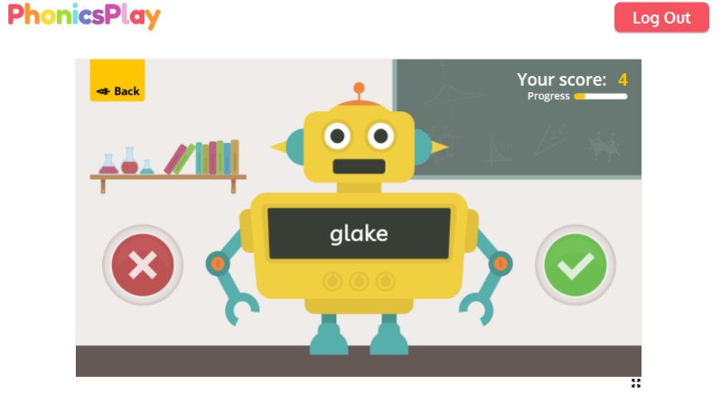

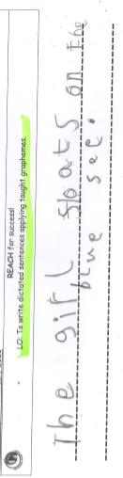

Spelling at The Crescent Primary School

Spelling sessions are taught daily across the school, but these are known as Phonics sessions in EYFS and KS1. As pupils follow the No Nonsense Spelling programme, they are taught the appropriate spelling rules and this covers the Government spelling word lists. In order to teach spelling, staff use a range of practical strategies to teach phoneme to grapheme recognition and then blending. Here are some examples:

Early years and Year 1 and Year 2 Years 3-6
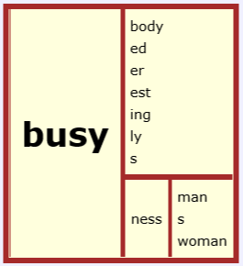
Continuous provision
Sand play
Water play
Sorting words – real words and
Nonsense words
Sound buttons

A spelling word matrices to support with morphology

Spelling homework:
Examples of Spelling homework in KS1 and KS2 – KS1 homework is primarily Phonics based for Phase 5 and 6 words including common exception words. KS2 pupils follow the scheme of No Nonsense Spelling and their weekly homework is derived from this.
Letter join to support spelling: Here are examples of how letter join uses the appropriate phonic sounds according to age related expectation and Government word lists later in KS2.
Early EYFS mark making Initial teaching of letters Initial teaching of words
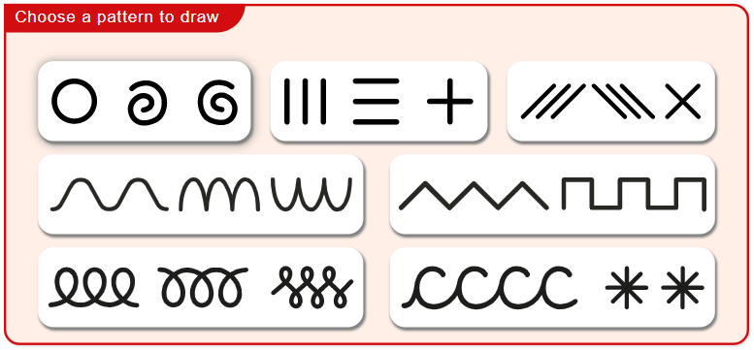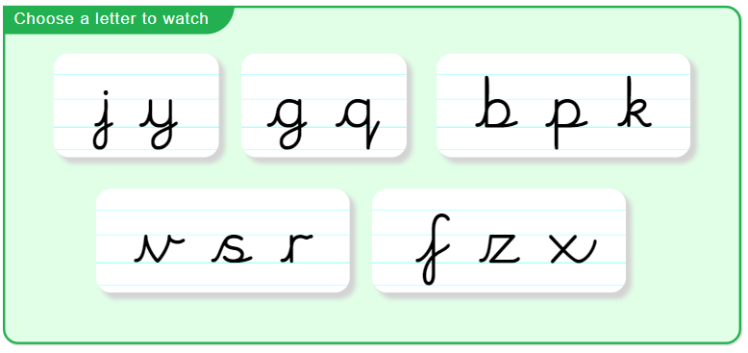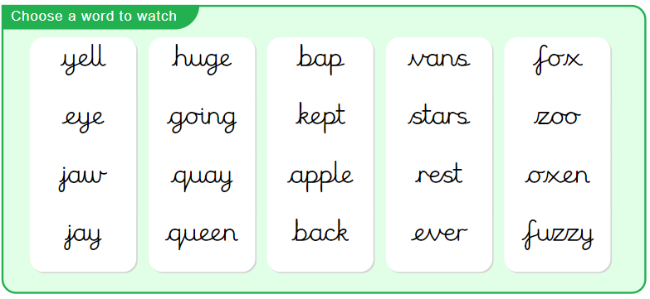

Year 2 example Year 5 example
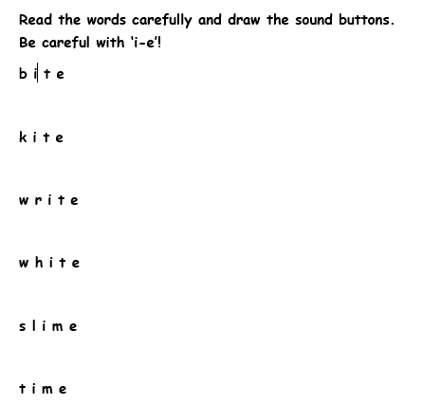
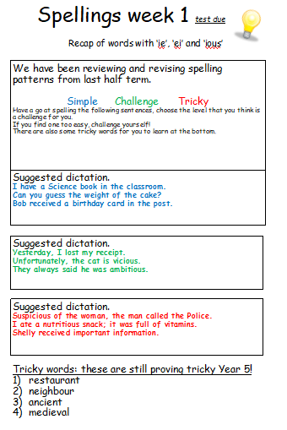
Spelling homework example:
KS1
KS2

Reading at The Crescent Primary School

Reading is an absolutely integral part of life at The Crescent! We love reading and we want to see each and every child develop a love of reading too!

Reading lessons
During the day, we have a Reading lesson, either daily for 30 minutes or 4 lessons of 40 minutes. In our Reading lesson, we use a mixture of whole class reading, where we use one text with the whole class, and independent groups. This is where we use ability set texts for each group. These two elements work seamlessly together: during the whole class phase of learning, skills are modelled by the teacher during the lesson. When the children then progress onto their independent learning phase, they apply these skills independently.
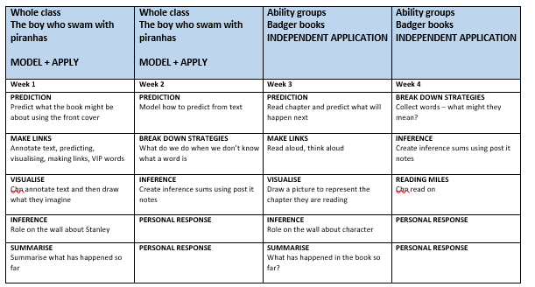
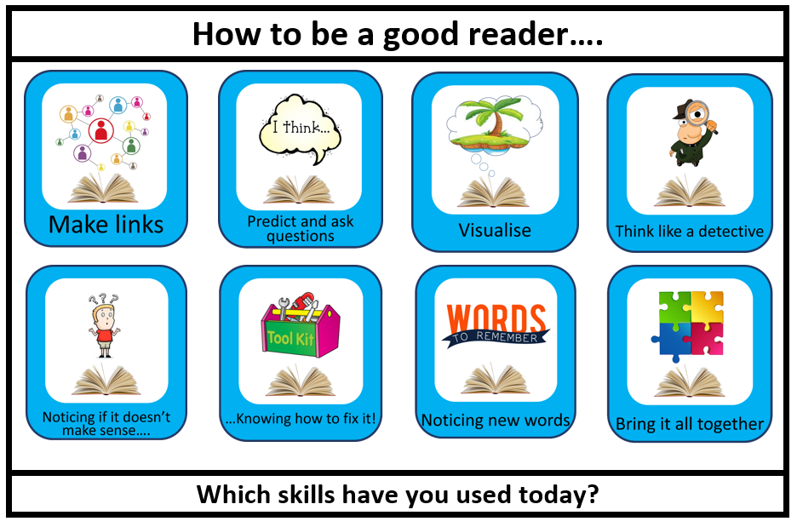
Texts are carefully chosen, that are rich and inspiring for the children to read. Links are made as appropriate with other areas of learning.
During the year, teachers assess the children’s reading regularly. This is either done informally by listening to children read, looking at written responses in the children’s reading journal, through a PM Benchmark or through a reading comprehension test. We use the NFER tests termly.
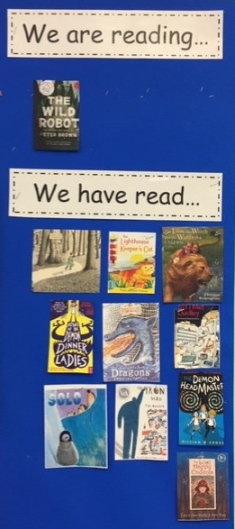
Reading for pleasure
We understand that for children make the best progress in reading when they love it! After all, practise makes perfect! We promote reading for pleasure all the time. Every day, teachers read their class a story book at the end of the day. We encourage the children to recommend favourite books to each other, and we celebrate the reading corner in each class through display and showcasing books to the children in the class. We also hold Reading Café events throughout the year – this is where parents and carers can come into school to read with their child, whilst enjoying a drink and a biscuit! The children not attending the Reading Café in the hall don’t miss out either: they enjoy their own squash and biscuits in the classroom too!
At The Crescent, we encourage the children to always try their best. We reward this with Dojo points. When the children reach 100 dojo points, they are able to choose a book in recognition of their hard work.
The Library
During each week, all children visit the library and are allowed to take 2 books out. Our librarian, Gerry Blakemore, is available to help children choose books. During the year, she organises each class to have a ‘date with a book’! Each term, every class can take 30 books from the library for their book corner.
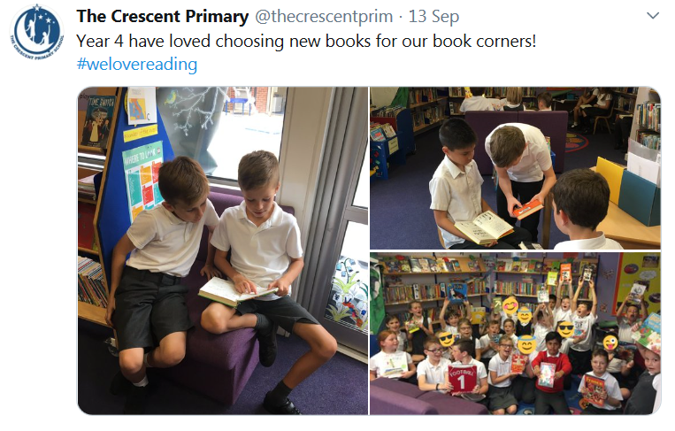
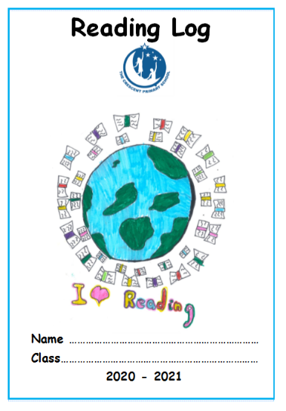
Home reading
Children are able to take home a book band book home with them. These are books that a teacher has assessed to be the appropriate level for them to access – these should not be too hard where an adult would need to help them read every word! Each child is given a reading log where they record their home reading. We expect children to read or listen to a story at least 5x a week for 15 minutes. Teachers are to sign the reading logs each week, noting children who are not reading regularly at home. The teacher should have a friendly conversation with the parent if this is the case. If it continues, the teacher would prioritise those children to be listened to by LSAs and Book Buddies. Children in Year R are given a reading puppy toy, funded by FoTC.
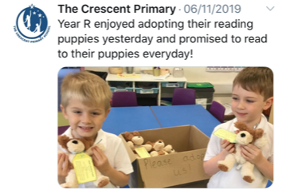

Writing at The Crescent Primary School

Our writing units are interwoven into learning journeys. These journeys are provided to the children at the beginning of each writing unit and discussed at the start of each lesson with the children. They have clear progression between skills and offer opportunities for pupils to practise their writing skills in ‘apprentice writes.’
Our written outcomes are always with a real, intended audience and have a clear purpose. Publishing, illustrating and presenting will always feature as the end goal for every learning journey.
Links between previous journeys and outcomes will embedded between units, year groups and Key Stages where appropriate.
In places, where learning can be better supported, pupils may study a text driver in both reading and writing.
An example overview of Year 2 Reading and Writing curriculum:
Writing across the curriculum is an important element to embed skills and provide opportunities for pupils to become more independent in their application.

An example Year 5 learning journey for English:
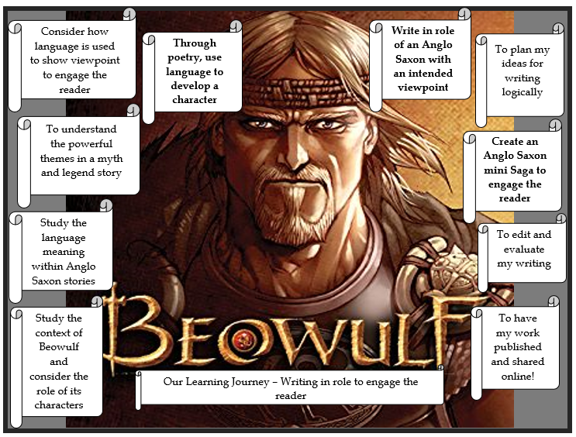

An example writing overview:
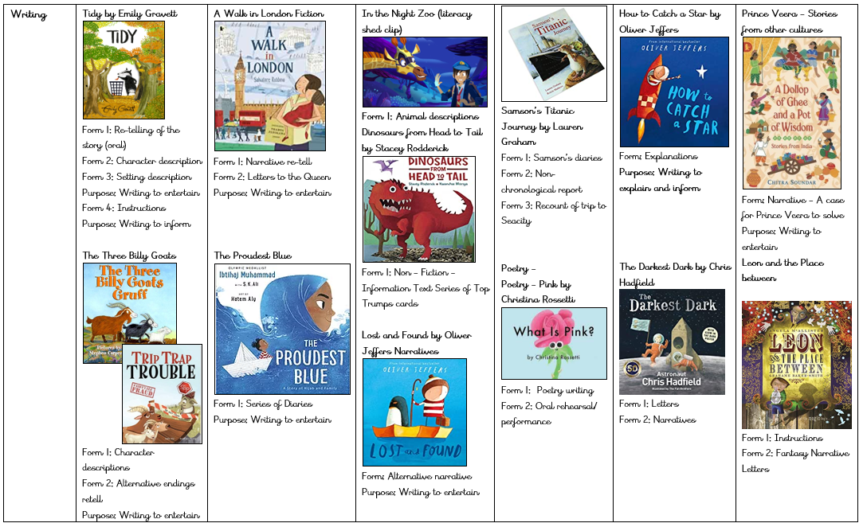

Vocabulary at The Crescent Primary School

Vocabulary has been, and continues to be, a core focus for learning across all subjects. We use Vocab Ninja as a stimulus for teaching and follow their vocabulary programme. When pupils use fantastic vocabulary in either spoken or written work, they will be awarded a Vocab Ninja ticket which will go into the Ninja box. In our weekly assembly, these tickets are raffled and the winner receives the Ninja mascot for their class.
Pupils have weekly vocabulary sessions in every year group, in place of one of their daily spelling sessions. Every classroom has a Vocab Ninja display for the teacher to update with the class word of the week. In SPAG books, pupils will record their learning about their weekly word of the week.
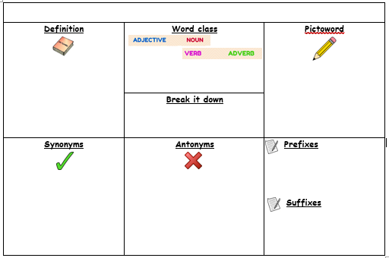
Here is an example word of the week grid used in lower Key stage two.
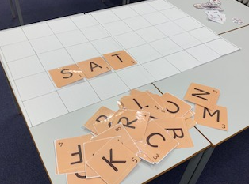
We use fun games for learning new vocabulary and to support our spelling – pictured is giant Scrabble
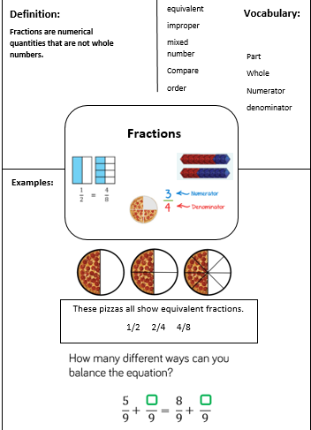
Mathematical vocabulary:
Pupils have vocabulary mats in maths to support learning at the start of each new topic. These should be referred to throughout the maths learning journey and used as a tool to support understanding of mathematical language.

Pre-teaching vocabulary:
Pupils are supported with pre-teaching of vocabulary within our English, topic and maths learning journeys. This is used to support them with accessing their learning.
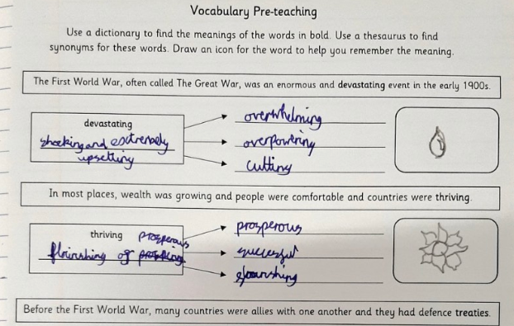
Assessment
The overarching aim for English in the national curriculum is to promote high standards of language and literacy by equipping pupils with a strong command of the spoken and written word, and to develop their love of literature through widespread reading for enjoyment. The national curriculum for English aims to ensure that all pupils:

- read easily, fluently and with good understanding
- develop the habit of reading widely and often, for both
Pleasure and information
- acquire a wide vocabulary, an understanding of grammar
and knowledge of linguistic conventions for reading,
writing and spoken language
- appreciate our rich and varied literary heritage

- write clearly, accurately and coherently, adapting their language and style in and for a range of contexts, purposes and audiences
- use discussion in order to learn; they should be able to elaborate and explain clearly their understanding of ideas
- are competent in the arts of speaking and listening, making formal presentations, demonstrating to others and participating in debate

Years 1-6 follow the Hampshire Assessment Model known as the HAM. Each year group is split into three phases which outline the expectations for each point of the year for pupils at the expected level.
Phase 1 expectations – linked to November
Phase 2 expectations – linked to February
Phase 3 expectations – linked to June
Ways that we assess in school:

On-going formative assessment or AFL is used across units. We use ‘Apprentice writes’ to help us to see the progress the children are making. We can then alter the planning and differentiation to challenge and support pupils further. At the end of our writing units, we have the Showcase Write whereby pupils have a further opportunity to apply their taught skills independently.

We will also recall learning from previous units so that pupils are able to show true mastery of a writing style.

Formal moderation across the school is held every half term for reading and writing and delivered by the English Subject leaders. These sessions are used to provide staff with up to date training and guidance of assessment in addition to moderation of reading and writing across teams and key stages to secure judgements.

Summative testing:
- Across the school, pupils are tested formally once per term for Reading, Spelling and Grammar.
- All pupils have a weekly Spelling test which is linked to their weekly Spelling homework.
- In addition, in KS1 PM benchmarking for reading occurs every half term
- Phonics tracking occurs every half term for KS1.
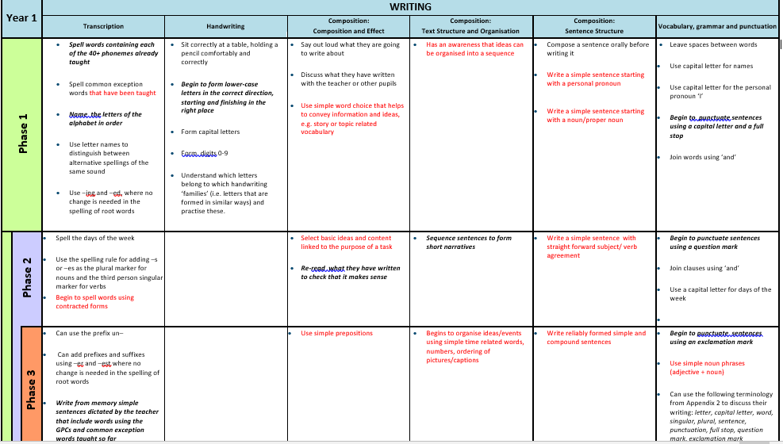
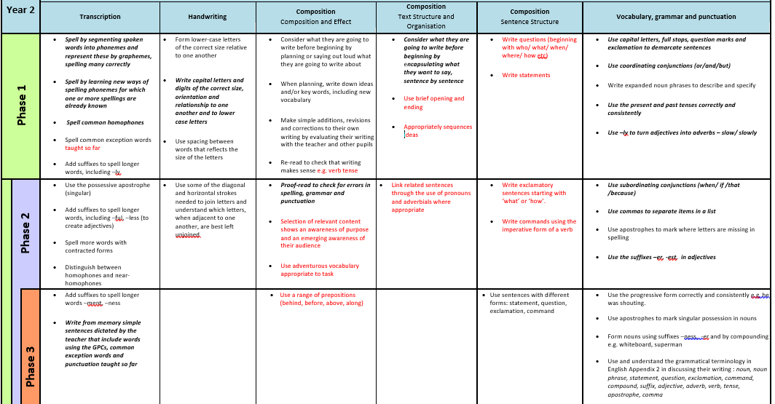
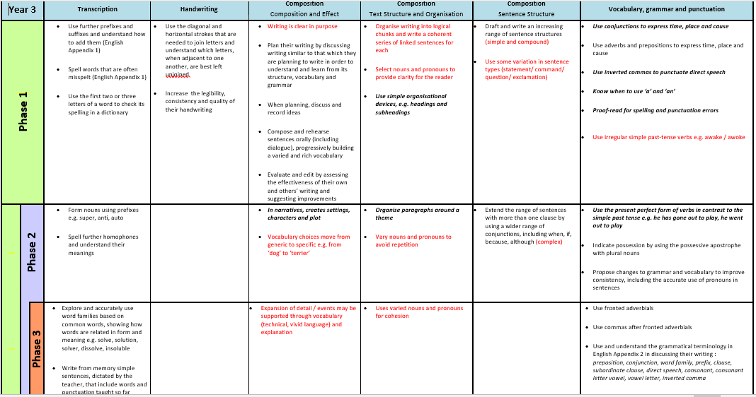

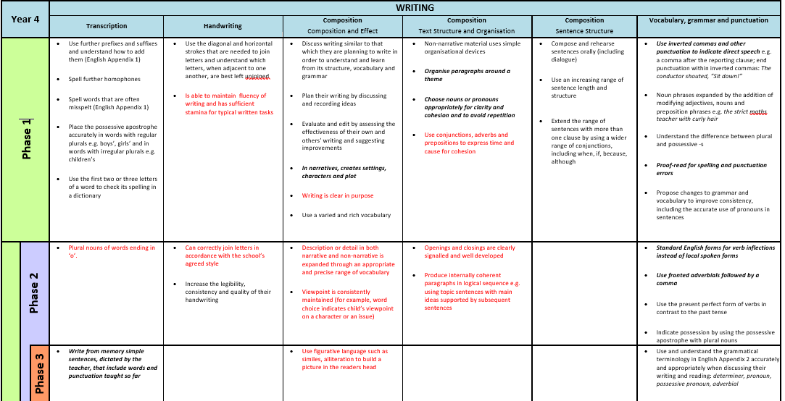
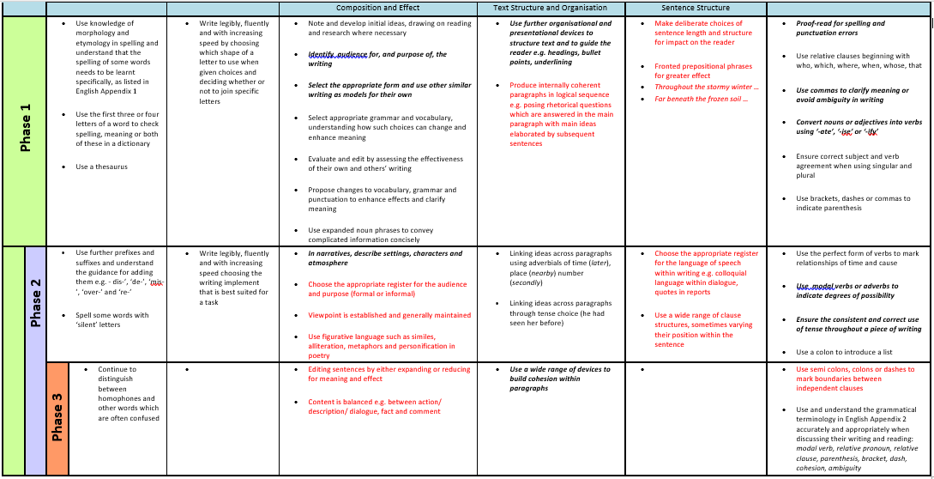

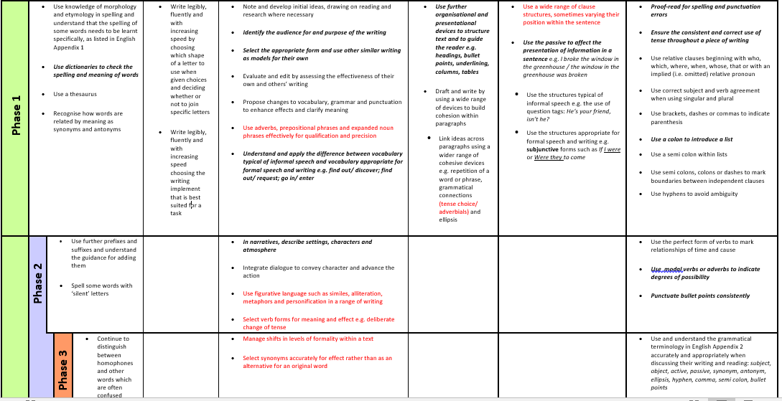
Progression
Here you will find the progression of text drivers across the school for all genres. These texts have been chosen to support the curriculum expectations for each year group. Text links have been embedded into this progression map to ensure that pupils are able to revisit skills and genres and continue to apply their learning independently.
Text progression:


